School Counsellor

Thank you for your interest in this position, which will be a key appointment in the further development of Friern Barnet School.

Attached are the following for your information:

• Current job description

On our website you will find an Application form and the school prospectus. All of this material will give you a clear impression of Friern Barnet School and its strong learning culture.

As the head teacher, I feel very privileged to be leading this school – a school community that is continuing its exciting journey of working together successfully to ensure that all students, whatever their ability, make excellent progress and enjoy and excel in everything they do.

The Governors and I look forward to receiving your application. Please note the closing date is on Friday 20 September 2019.

Yours sincerely
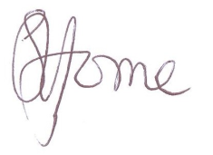
Simon Horne
Head Teacher

