

Information for Applicants

Main Grade Primary Class Teacher
City of London Primary Academy Islington




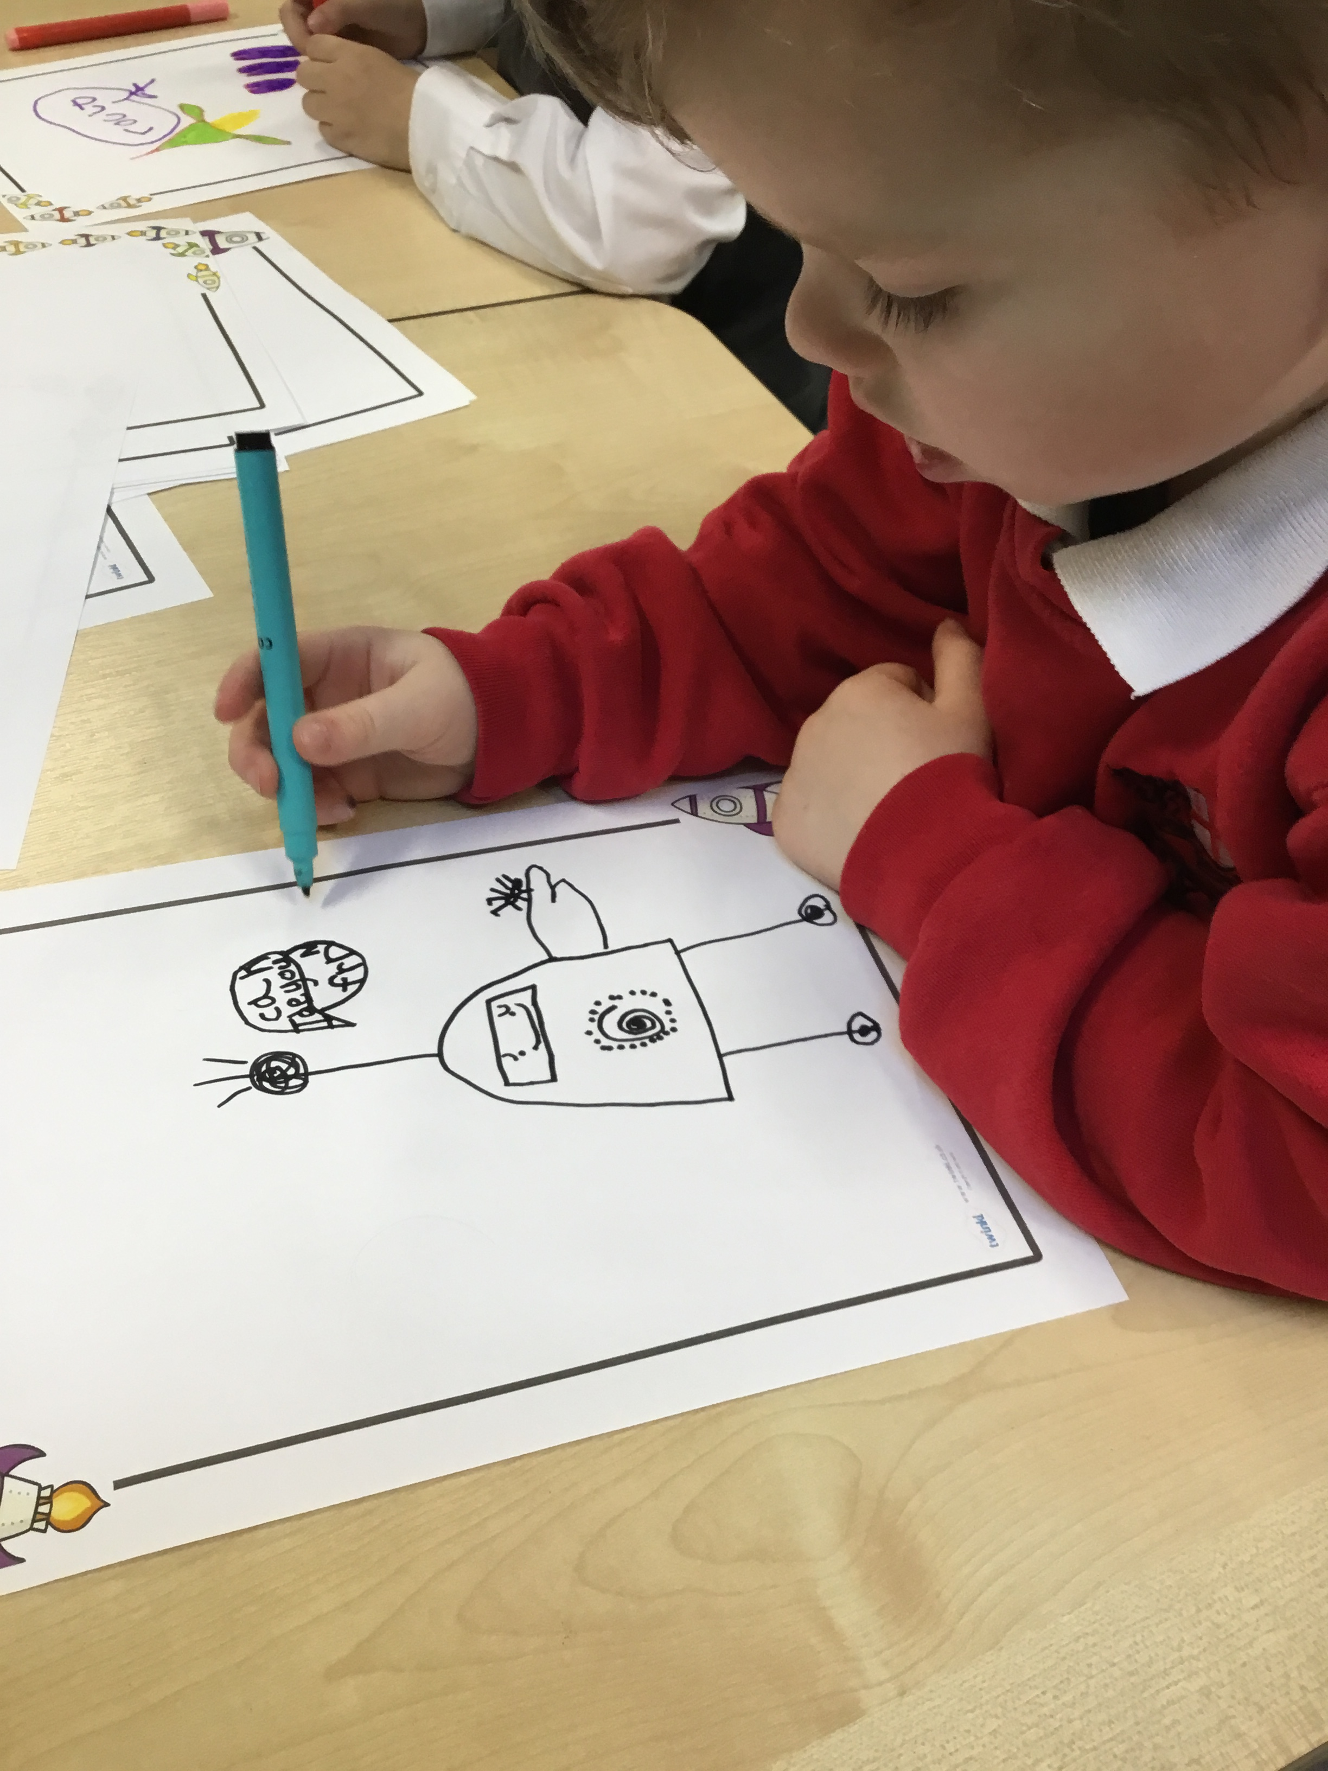
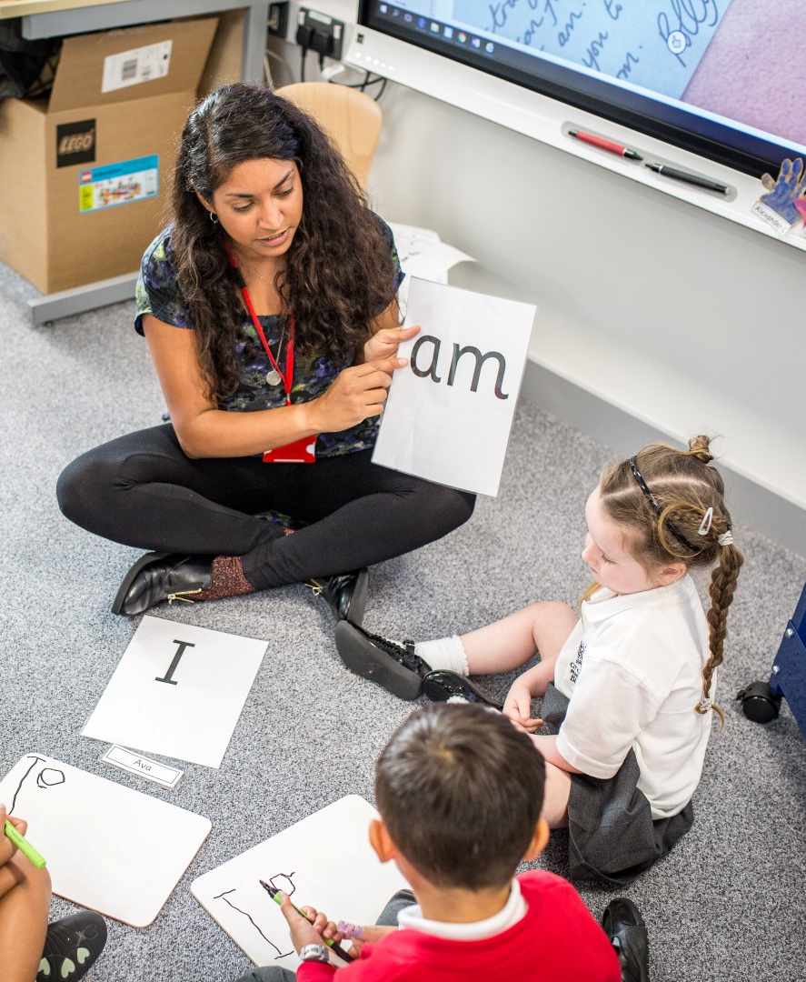



City of London Academies Trust
Guildhall, PO Box 270
London EC2P 2EJ
020 7332 1432
enquiries@cola.org.uk
www.cola.org.uk

Dear Applicant,

I am delighted that you have chosen to apply for a post with the City of London Academies Trust.

COLAT is driven by the ambition to provide world-class experiences and deliver exceptional educational outcomes for the young people we serve. Combining the heritage and traditions of the City of London Corporation with an innovative and enterprising approach to teaching and learning, we aim to ensure that every one of our schools can be judged as ‘outstanding’ within three years of joining our Trust.

Our expectations are high for both our students and our staff. Our ‘Foundations of Excellence’, which run through all Trust schools, have been the framework for our sector-leading success so far. These core principles have led to the City of London and COLAT being recognised as the best performing academy chain for progress and attainment of disadvantaged children for two years in a row in The Sutton Trust’s annual report, ‘Chain Effects’ (2016 and 2017). This fuels our determination to continue to develop the work we do, while remaining focused on the ambitions for our schools and making a significant difference to children’s lives.

In striving for excellence in all aspects of our work, we are acutely aware that this will only be achieved through hard-working and motivated staff. We therefore ensure that we invest in our people, allowing them to grow and achieve their career goals within the Trust or beyond. We are committed to providing first-rate training and development opportunities to all our staff, in addition to excellent career advancement opportunities within our growing Trust. In the classroom, we expect the kind of exemplary behaviour that allows our staff to generate exceptional learning outcomes for our children. Being sponsored by the City of London Corporation also means our staff benefit by having access to a huge range of resources, events and exciting learning opportunities that other Trusts are simply not able to offer.

We are always looking for like-minded individuals to join us on our journey. Making the choice to work for COLAT means making the choice to be part of an evolving, ambitious and supportive Trust where you are valued, encouraged and can develop your specific talents whatever they may be. We look forward to receiving your application.

Yours faithfully,

Mark Emmerson
Chief Executive Officer


VAT Reg: 280 4820 09
Company Reg: 04504128
The City of London Academies Trust is part of the City of London Corporation


City of London Primary Academy Islington
C/O Copenhagen Primary School
Treaty Street
N1 0WF
020 7 504 0556
office@islingtonprimary.cola.org.uk

Head Teacher’s Welcome

Dear Applicant,
Thank you for applying for the position of a Primary Main Professional Grade Class Teacher for the City of London Primary Academy Islington (COLPAI). As our school expands, we will have a vacancy for the academic year 2021/22. I am delighted you have chosen COLPAI as a school in which to develop your teaching career. This post offers enormous potential to work collegiately as part of an exceptionally talented and growing team, to maintain the growth of this Outstanding school for the next generation of children.

COLPAI opened in September 2017. Currently, our school has children from Reception through to Year 3 and from September 2021 we will have Year 4 pupils. The school is growing, year on year, and will reach its full complement of 420 pupils by 2024. The school is temporarily located within Copenhagen Primary School building while our own brand new school is built near to Golden Lane, EC1. We will be moving into our new building at the end of July 2021. Our new school will offer a world-class education facility within a fabulous learning environment. We are a fully inclusive school and our pupils, including those with SEND, are drawn from and reflect the vibrant and diverse local area. Once settled into our permanent site, we plan to expand EYFS provision to also include nursery and two-year-old places.
Situated on the doorstep of the City and surrounded by world-class cultural resources, this is a school that inspires a love of learning and equips all pupils to fulfil their ambitions. It benefits from the expertise and resources from the City of London family of schools and is supported by The City of London Corporation enabling staff to benefit from the rich arts and cultural resources the City has to offer.
COLPAI is judged by Ofsted to be an Outstanding school in all areas. We believe in setting ourselves high expectations and in doing whatever it takes to achieve them. We have an exciting curriculum, both creative and challenging, underpinned by outstanding pastoral care and a nurturing environment that will allow all our children to flourish. Pupils have impeccable behaviour and are keen to learn. As a school, we are ambitious to achieve Outstanding outcomes for all of our pupils, regardless of their background. COLPAI pupils achieve Outstanding results, ranking it as one of the top performing schools locally and nationally. Our strong partnership working ensures we share resources, expertise and skills across our family of highly committed professionals to provide a world-class education that will transform pupils’ lives.
We are delighted to have been chosen as the Barbican’s Associate Primary School for the next three years; this means we will benefit from bespoke CPD opportunities and collaborate with internationally renowned creative professionals spanning all areas of the arts. In addition, the programme offers many bespoke synergies and collaborations with the organisations of the Culture Mile to ensure our curriculum offer is broad and balanced and second to none.
This is, without doubt, one of the most exciting posts available to any prospective candidate wanting to join an Outstanding school and make the perfect start to their early teaching career and make a difference to children lives in a vibrant, culturally diverse inner-city school. If our values, ethos and ambitions resonate with yours, we would love to hear from you.

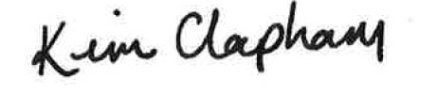
Yours faithfully,

Kim Clapham
Head Teacher

Title: 1 Main Professional Grade Primary Class Teacher
Description: Permanent, Full Time

Location: City of London Primary Academy Islington

Closing Date: 9:00am, Friday 23rd April 2021

Interviews: Friday 30th April 2021

About us
The City of London Academies Trust is driven by the ambition to provide world-class experiences and deliver exceptional educational outcomes for the young people we serve.

Combining the heritage and tradition of the Corporation of London with a refreshingly innovative and enterprising approach to teaching and learning, we aim to ensure that every one of our schools can be judged as Outstanding within three years of joining the Trust.

Our academies draw upon the best traditions, institutions, heritage and historical successes of the City Corporation and London. We deliver life-transforming learning experiences allowing all our pupils, whatever their background, to make a positive contribution to their local, national and global communities.

The City of London, its schools and academies are characterised by:

- High expectations, aspirations, excellence and a belief that all can succeed;
- Combining creativity, innovation and enterprise, alongside tradition and continuity;
- Developing people who are confident, resilient, compassionate and democratic.

Although all schools within the Trust are different, they all subscribe to the same ethos. All City academies are expected to exhibit the five attributes of outstanding educational provision. These simple and effective principles, our Foundations of Excellence, are the essential drivers that deliver outstanding outcomes for learners and are key to the success of City of London academies. They are:

High expectation leadership | Dynamic and skilled leadership from school leaders and governors founded in the core belief that all children can succeed.
Exemplary behaviour | Behaviour for learning based on a set of defined core values that promote engagement, respect, tolerance, probity, curiosity, resilience, creativity and independence.
Outstanding creative teaching | Highly skilled teaching that inspires, engages, supports and challenges learners whatever their starting point.
Assessment that informs intervention | Target-setting and assessment systems that set challenging targets and provide data that supports intervention if that progress is not being made.
A challenging curriculum | A formal curriculum that matches the high expectations of progress providing a range of high status qualifications for each learner. A rich informal curriculum that supports the wider development of each learner through personal, sporting, creative and employer experiences.

About our school
City of London Primary Academy Islington (COLPAI) opened in September 2017. COLPAI is a non-selective, fully inclusive school. Pupils are drawn from and reflect the local community. Our vision for COLPAI reflects a passionate commitment to offer a world class education based upon the highest expectations of ourselves and our pupils. Our new school is part of a family of highly successful City of London schools and we are rated Outstanding by Ofsted in all areas (December 2019).

The school is temporarily located on the third floor of Copenhagen Primary School building, offering a world-class learning environment while our own state of the art school is built.
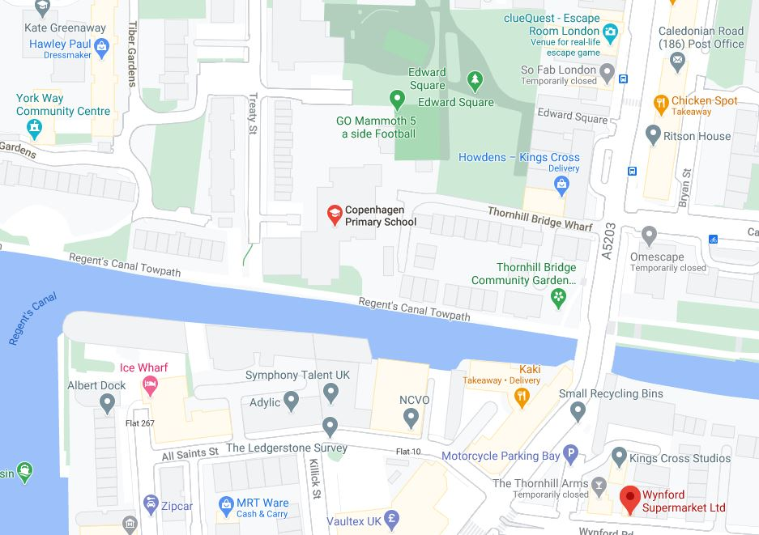
Temporary address
City of London Primary Academy Islington
C/O Copenhagen Primary School
Treaty Street

London
N1 OWF.

Nearest station: King Cross.

We will be based in temporary accommodation until July 2021 when we plan to move to our brand new school on what was the old Richard Cloudesley School site, to the north of the Golden Lane Estate. Hawkins Brown, award winning architects, based in Clerkenwell, have been appointed to design our very exciting new school.
For more information on the project please visit the website at http://colpai-project.co.uk/


The local attractions all within 10 minutes walking distance of the new school site include The Barbican, Museum of London and Whitecross Street Food Market.

Bus routes: 55, 243, 4, 56, 153
Nearest station: Barbican underground, Old Street underground

If this role is of interest to you and you can contribute to our future success, an application pack is available on the Trust website, www.cola.org.uk. If you require any other details, please contact Ms Kim Clapham on 020 7504 0556 or office@islingtonprimary.cola.org.uk.

How to complete the Application Form

It is essential that a fully completed application form is submitted. City of London Academies Trust cannot accept CVs alone. It is recommended that you retain a copy of your application form, so you can refer to it if you are invited for interview.

The main sections of the application form ask for various information relating to your work, educational and personal history. This information allows your application to be fully assessed against the criteria/competencies required for the job. When completing the application, you should provide your entire work history, including a description of any gaps in employment. In addition, outline your skills, qualifications and any notable awards. These can be selective, and you only need to provide those you consider relevant to the job you are applying for.

Section 5 is the most significant element of the application form. Using no more than two sides of A4 please provide an accompanying letter explaining why you are applying for this post and how your experience, skills, training and personal qualities match the requirements of the role as set out in the job description and person specification.

As part of your letter of application, we are interested in knowing your impact so please provide relevant evidence. For instance, if you are seeking a pastoral role provide relevant data on the reduction of exclusions. If seeking a teacher role provide progress and attainment, data of classes taught. If you do not meet all the essential criteria, it is unlikely that you will be shortlisted.

City of London Academies Trust asks that all potential employees highlight any relationships to school governors or employees to ensure all applicants are treated fairly. For example, it may be inappropriate to offer someone a position within an organisation where they work for a family member or asking someone to take a position where they manage grants for voluntary services when their family works for a relevant voluntary organisation.

City of London Academies Trust is committed to safeguarding and promoting the welfare of children and young people, and applicants for vacant posts are expected to share this commitment. If you are offered a job, the offer will be conditional on satisfactory pre-employment checks. These can include: identity, references, qualifications and other evidence, e.g. driving licence, as well as a medical questionnaire, and a Disclosure and Barring Service (DBS) check.

Please provide details of two referees, one of whom should be your present/most recent employer. References will not be accepted from relatives or friends. References are requested for all shortlisted candidates unless you specifically request us not to do so. Open references will not be accepted.

This post is exempt from the Rehabilitation of Offenders Act 1974. If you are appointed, you will be required to complete a DBS check. Any information received from the DBS will be treated in the strictest confidence. Having a criminal record will not exclude you from appointment, unless it is considered that the conviction renders you unsuitable to work with children.

Under the Criminal Justice and Court Services Act 2000, it is a criminal offence if an individual who is disqualified from working with children knowingly applies for, offers to do, accepts or does any work with children.

The role is covered by part 7 of the Immigration Act 2016 and therefore the ability to speak fluent spoken English is an essential requirement for this role.

Please email your application form to the email address provided in the advert. If posting an application, please ensure the correct postage is paid and that it is sent with enough time to be received before the closing date. City of London Academies Trust cannot be held responsible for postal issues or errors.

