**Job Application Pack**

**Darland High School**

**Second i/c English Department**



Headteacher Joanne Lee

**Salary: MPS/UPS + TLR 2B**

Permanent - Full Time

Start date: September 2021

Closing Date:

**12:00 noon, Wednesday 14th April 2021**

Interview Date:

**Friday 23rd April 2021**

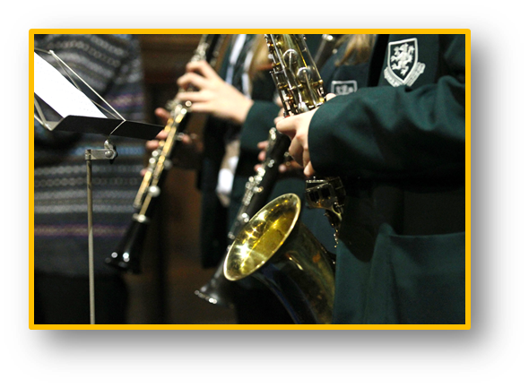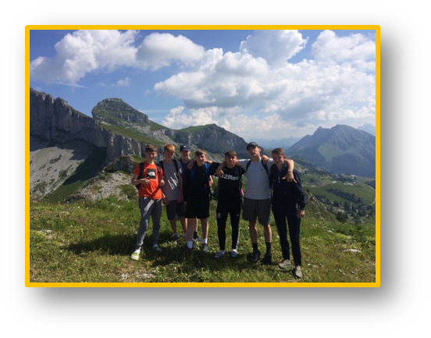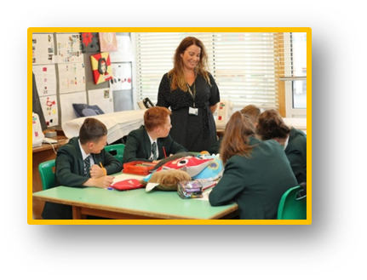

**Darland**

**High School**



# **Letter from the Headteacher**

Dear Colleague,

Thank you for your interest in working at Darland High School.

I am immensely proud to be the Headteacher here at Darland and I want everyone who comes to Darland High School to be an equally proud member of our family. Our work is about making a real difference to the lives of children so that they in turn make a discernible difference to their communities, our town and our world.

We serve a diverse community in North East Wales, ranging from high levels of disadvantage and deprivation to affluent areas of rural Wrexham, and we work as a team to provide all our students with the best education and opportunities to inspire them to be successful.

Our students are at the heart of everything we do at Darland High School, every child matters to us and we believe that every child can succeed. Our moto is ‘Aspire, Apply, Achieve’, our expectations for academic standards and behaviour are therefore unapologetically high.

I was appointed as Headteacher in September 2019, and although all schools now find themselves in unchartered territory, we are undoubtedly on a journey of change with our sights set on becoming an excellent school. We have a dedicated team of over 135 staff who work together tirelessly with this goal in mind.

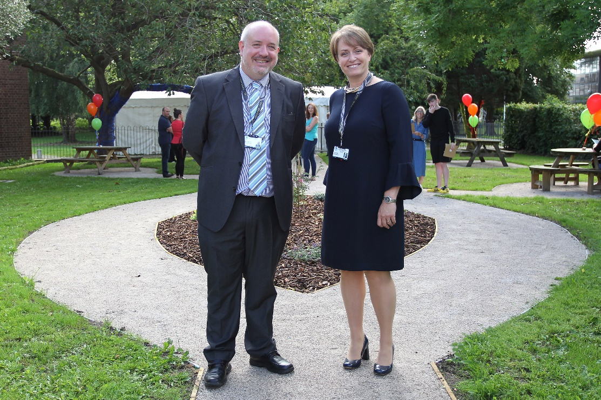I look forward to reading your application.

Kind regards,

Joanne Lee

Headteacher

Chair of Governors, Cllr Rob Walsh & Headteacher, Joanne Lee

# **Darland Green Logo (Welsh)Application Details**

Thank you for your interest in the Second in Department - English vacancy at Darland High School. We are looking for a passionate and driven individual to make a contribution to the current team at Darland High School.

Further details of this post can be found in this pack and details of the school can be found on our website which is currently being updated. Details of how to apply can be found below:

# How to Apply

Should you wish to apply for the post, please complete and return the Wrexham Authority application form and the school’s safeguarding self-disclosure form directly to the school along with a covering letter addressed to our Headteacher, Mrs. J Lee, which clearly demonstrates your suitability for this role.

Application pack and safeguarding self-disclosure forms can be downloaded from our website and submitted via email to [headteacher@darland.wrexham.sch.uk](mailto:headteacher@darland.wrexham.sch.uk) with Second in English Department in the subject line, or by post for the attention of Mrs Lee, to the following address:

Recruitment

Darland High School  
Chester Road  
Rossett  
Wrexham  
LL12 0DL

**Application forms & safeguarding self-disclosure forms:** These can be downloaded from the school website at <https://darland.wrexham.sch.uk/vacancies/>

Wherever possible, please provide email addresses for your referees.

**Closing Date:** Please ensure your application arrives by 12:00 noon on the closing date of **Wednesday 14th April.**

**Interview:** Interviews for the role will be held on **Friday 23rd April**.

**Safeguarding:** Darland High School is committed to safeguarding and promoting the welfare of children and young people. We expect all staff and volunteers to share this commitment. All new staff will be subject to an enhanced DBS check and the school’s self-disclosure process.