Dear Applicant

Thank you for the interest you have shown in this post at Ysgol Rhosnesni High School.

We believe that this is an exciting opportunity and that the successful applicant will be joining a happy and welcoming community.

Our school is currently a Pathways to Success School and we are committed to developing the learning environment and life chances of all children in our community. Having demonstrated great improvements the school is continuing to achieve positive outcomes for students. We are now looking to appoint a strong and inspirational teacher and leader to join the school to drive improvement, develop a strong and powerful school ethos and implement our vision for the future. If you have that drive and ambition and are a strong and inspirational teacher, then this is an unparalleled opportunity to join our school on our journey towards excellent.

The ethos at Ysgol Rhosnesni is very special. As a Pathways to Success School, we emphasise the enjoyment of learning within a caring, purposeful and stimulating environment, where individual students matter and their well-being and success are paramount.

At the heart of any harmonious, ambitious community lie personal relationships which encourage, challenge and enable all members to give of their best. We therefore seek to provide the highest quality educational opportunities for all our students.

At Ysgol Rhosnesni we aim to make a positive difference to the future life-chances of each and every young person. Ysgol Rhosnesni High School is justly proud of the achievements of its students in a wide range of fields.

Our mutual ambition, therefore, is for our young people to thrive within their future roles as students, citizens, workers and lifelong learners and aim to equip them with the necessary skills, knowledge and understanding they will need for future adult life.

Visits to the school are welcome. Please contact the PA to the Headteacher, Mrs J Maclean to arrange a mutually convenient time to visit on 01978 340847.

A copy of the school prospectus and further information is available from our school website at http://www.rhosnesni-high.wrexham.sch.uk/pdf/prospectus.pdf

We look forward to receiving your application and to learning what you would be able to offer our school and specifically its students, staff, parents and governors. Please return completed applications directly to the Headteacher at the school.

Yours sincerely
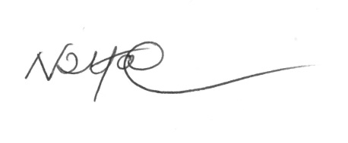
N D Harrison
Headteacher

