HMC Boarding and Day
670 Boys; 275 Sixth Form

Biology Teacher (fixed term contract)



Bedford School

Situated just 35 minutes on the train from London St Pancras, and half way between Oxford and Cambridge, Bedford School is one of the region’s leading boarding and day schools, educating boys from the ages of 7 to 18. Part of The Harpur Trust, Bedford’s leading educational and social welfare charity, we’re a vibrant school with a very strong sense of community, set in a beautiful 50-acre estate in the heart of the town.

There are approximately 700 pupils in the Upper School aged 13 to 18, with roughly 280 in the Sixth Form. 35% of the boys are boarders in our six Boarding Houses, each of which is “twinned” with a Day House. Our Prep School with 400 boys caters for the 7-13 age range on the same campus, and has its own junior Boarding House.

Academic excellence is central to life at Bedford School, and we encourage boys to aspire to the highest possible standards and to exceed their expectations. Our success is demonstrated by a long history of impressive exam results at GCSE, A level, and in the International Baccalaureate Diploma. The vast majority of our leavers go on to Higher Education, and over two thirds of our Upper Sixth boys accepted places at Russell Group universities in 2018; 75% of boys went to universities in the Top 30, to specialise in particular areas of expertise. We are seeing our boys diversify their applications, with more expressing an interest in degree-level apprenticeships and universities in the USA and Europe. Typically, between five and ten boys take up places at Oxbridge each year.

The School was inspected in November 2016, and we are particularly proud of the fact that ISI (Independent Schools Inspectorate) gave us the top ratings possible. Full details, including a copy of the inspection report can be found here:
http://www.bedfordschool.org.uk/Inspection-Report

The school adopts a selective entry policy without being ruthless and seeks to provide an environment where all boys will thrive academically. It emphasises continuity of education at 13+ and 16+ so that, although there are academic entry requirements at each point, they are geared to whether boys are suitable to move to the next stage rather than over-formulaic targets. We believe in an all-round education that exposes all boys to a wide range of experiences and opportunities.

We place great emphasis on the value of Sport, Music and the Arts for the camaraderie, teamwork and self-motivation they instil, and encourage boys to explore their individual talents. Our extensive programme of extracurricular activities is wide-ranging and offers boys the opportunity to learn new skills and discover new interests outside the classroom. Boarding is at the heart of the school and all full-time members of staff are expected to contribute to the wider life of the school through involvement in the tutoring system and in activities outside the classroom.

The school’s ongoing development programme has included the construction of a new Library (2003), Observatory & Planetarium (2003), a new Music School (2006) and a wonderful new theatre in St Luke’s Church, on the edge of the estate (2015). Other developments have included renovation of the school dining halls and kitchens (2009), fitness suite (2010), staff common room (2011), sports pavilion (2012) and science department (2015).

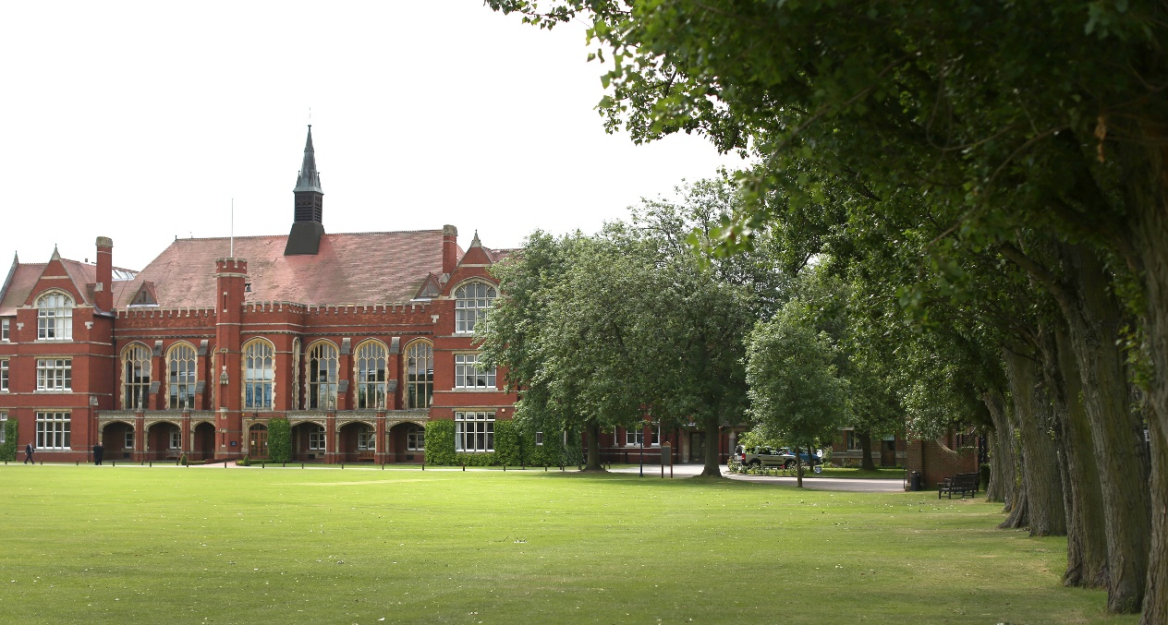

The Biology Department

The Science Department benefits from a purpose built centre with all three departments, though separately organised, being in one building. The Science Department has recently undergone a £2.5 million refurbishment. The laboratory facilities offer an excellent teaching environment for Science at all ages; in particular the development of experimental and investigative work is encouraged.

The Lucas Wing, which houses the Biology Department, comprises six modern teaching laboratories, a 6th form teaching room, a staff room and a preparation room with further storage facilities. The Biology Department has produced very large amounts of shared online teaching and learning resources - available via Firefly and the in-school network drive - to support staff and boys in the study of Biology. There are six full time teachers and one part time Biology teacher, with one full time and one part-time technician. Close links are maintained with the Physics, Chemistry and DT Departments, to form a Science Faculty under the leadership of the Head of Science. The Biology Department is also fortunate to have its own 140-acre field-study centre at Ickwell, whose teaching laboratory, lecture room, woodland and lake areas are used for Ecology and Active Conservation work.

IGCSE courses are organised to start in Year 9 and lead to external examinations at Key Stage 4 in the Edexcel IGCSE ‘Double Award’ Sciences or in the ‘Triple Award’ Separate Sciences. At present there are eight Year 11 sets, five of which are Triple Award, two are Double Award and one is for ‘Pre-IB pupils. The size of teaching sets varies - according to ability - from (no more than) twenty-four, to ten. Results at IGCSE have been very good, with 97% A*- B and 85% A*-A at Triple Award.

There are approximately 98 6th Form boys who study either AQA A-Level or the IB. A-Level results have also been very good. On average 75% of boys achieved A*- B grades at A level, with c.100% gaining grades A-D. Both Higher and Standard Level International Baccalaureate Biology are taught at Diploma Level; approximately 84% of boys gained level 7-5. Careers in Medicine are given special attention, along with preparation for Oxbridge entry.

The Biology Department organises the Biology Society lectures, where Boys are often found giving talks to their peers, as are visiting speakers. In addition, the Harpur Science Forum - a collaborative venture between Bedford School and Bedford Girls’ School and to which all local schools are invited - brings top speakers into School to inspire young scientists. Recent lecturers include Lord Robert Winston, Professor Steve Jones FRS, Baroness Susan Greenfield, ex-Director of The Royal Institution of Great Britain, along with Professor Christopher Phillips, Dean of Imperial College Natural Sciences and Professor Hugh Montgomery, leader of the Xtreme Everest Expedition, who gave one of the recent Channel 4 Royal Institution Christmas Lectures.

The Department encourages staff and boys to attend lectures in London at the Royal Institution, Royal Society and other Biology Symposia. Boys perform strongly in the British Biology Olympiad, Biology Challenge and the Biology Challenge, with Gold medals won annually. The Lower Sixth take field trips to our Field Study Centre and to Dorset. Three major expeditions have recently occurred: 27 boys went on expedition with Operation Wallacea to Peru’s flooded rainforest, where they worked as ‘surveyors’ in very difficult conditions, 16 boys conducted a reef survey and engaged in reef repair work in the Bahamas on San Salvador Island with Earthwatch and last summer saw 23 boys learn to scuba dive and survey reefs off Cuba with Operation Wallacea.

The Role

We wish to appoint a teacher for January 2019 who is enthusiastic and well qualified, to join a large, highly successful and thriving department. This post is for a fixed period, for the Spring and Summer terms of 2019, with the possibility of a third term in Autumn. The successful candidate will have a genuine passion for Science and a desire to inspire this in others. They will also be eager to develop their own teaching skills and share ideas with colleagues.

We welcome applications from experienced teachers or NQTs from a wide range of backgrounds. We are also equally happy to consider applications from those without professional qualifications in teaching, if they are well qualified in Biology (or a related field).

Benefits of Service

Bedford School has high expectations of its staff and therefore looks to reward them with generous salary scale increments and beneficial conditions of service. All teachers are offered membership of the Teachers’ Pension Scheme and have longer holidays than the maintained sector. Class sizes are small (maximum of 14 at Sixth Form and 24 at GCSE) and most teachers have their own classroom. A wide range of opportunities for professional development exist and staff are encouraged to develop their skills and consider career options at all levels. There is ample opportunity to take on additional responsibilities for which there are allowances.

Fee concessions are available across the Harpur Trust schools. A private health care scheme is also available for teaching staff.

Bedford is set in beautiful grounds and staff are welcome to make use of the extensive leisure and sporting facilities (which includes gym, swimming pool, tennis courts, squash courts etc.) for themselves and their immediate family.

All staff enjoy free on-site parking. Lunch (of outstanding quality) and free refreshments are available throughout the day; other meals are available according to staff commitments.

Each member of the teaching staff has a voice on professional matters via the Common Room Chair, and all staff are encouraged to contribute to the Teaching and Learning Group. The ability to join a strong community through a number of social events (Staff Bar, Staff sports leagues etc.) is encouraged.

Bedford is a dynamic and incredibly rewarding place to work with a strong sense of community.

General Information

Full-time teachers at Bedford are expected to:
• Play a full part in the extensive games and activities programme
• Be a Tutor attached to a boarding or day house

Bedford School is committed to safeguarding and promoting the welfare of children and young people and expects all staff to share this commitment. Offers of appointment are subject to satisfactory references and DBS clearance.

Staff are normally expected to find their own accommodation, although there may be some school accommodation available in certain circumstances.

Application Process

Applicants are asked to complete the School Application Form; CVs in place of an Application Form cannot be accepted.

Short-listed candidates will be invited to the School for interview on the advertised date. The selection process will involve a lesson observation and several interviews.

The Head of Science and Biology, Mr Mike Beale, FRSB, would be happy to talk to prospective applicants; he can be contacted through the School Reception on 01234 362200 or by email mbeale@bedfordschool.org.uk

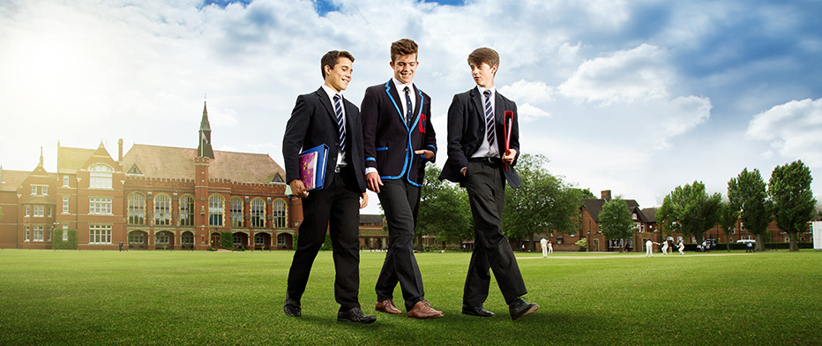
Bedford School is part of The Harpur Trust

