Cedar Mount Academy
Gorton Education Village, 50 Wembley Road,
Gorton, Manchester, M18 7DT
VACANCY: VICE PRINCIPAL
CEDAR MOUNT ACADEMY
INFORMATION PACK

CONTENTS

HOW TO APPLY | Page 3
ABOUT BRIGHT FUTURES EDUCATIONAL TRUST | Page 4
BRIGHT FUTURES EDUCATIONAL TRUST’S STRATEGY | Page 5
CEDAR MOUNT ACADEMY – HISTORY & CONTEXT | Page 6
CEDAR MOUNT ACADEMY – PUPIL INFORMATION | Page 7
CEDAR MOUNT ACADEMY – STAFFING STRUCTURE | Page 8
VICE PRINCIPAL JOB DESCRIPTION | Page 9
VICE PRINCIPAL PERSON SPECIFICATION | Page 11

HOW TO APPLY
This information pack is designed to provide you with further information on Bright Futures Educational Trust, Cedar Mount Academy and the role of Vice Principal at this academy. If having read the information and you want to apply, please:

Complete the application form, with a covering letter (no more than two sides of A4 please)

Email the application form and letter to vacancies@cma.bfet.uk, or post it to be received by Sunday 19 May.

Closing Date Sunday 19 May 2019
Shortlisting by 20 May
Selection process, we expect this to be over two days: Wednesday 22 and Thursday 23 May

Bright Futures Educational Trust
ABOUT BRIGHT FUTURES EDUCATIONAL TRUST
The best for everyone, the best from everyone

Bright Futures Educational Trust (BFET) was established in 2011 and comprises 7 schools in the Great Manchester and Blackpool areas, a teaching school (Alliance for Learning), Maths Hub and School Centred Initial Teacher Training and the central head office team.

Our schools are their own entities and form one organisation and one employer, BFET. The BFET Board of Trustees maintains strategic oversight of the Trust and delegates some of its responsibilities to the Executive team, Principals and local governing bodies. We place a high value on integrity and probity and take seriously our accountabilities for making the best use of public money. How decisions are made is described in our delegation framework. You can find out more about the Trustees and the Executive Board on our website: http://bfet.co.uk/about-us/

Collaboration and strong relationships form one of the ‘commitments’ in our Strategy and all components of the BFET family work closely together. Our Strategy was developed collaboratively and is contained in this pack for your reference. We are in the process of engaging with all staff across the trust in reviewing this work.

The Alliance for Learning is our Teaching School and partners with many schools across the North West, including our own. The Teaching School includes a maths hub, a SCITT, a broad range of professional learning and wider network opportunities. Please see the website for more details http://allianceforlearning.co.uk/about-us/welcome-director-of-teaching-school-and-partnerships/

The head office team, comprises the Executive team: John Stephens, CEO; Edward Vitalis, Finance Director; Gary Handforth, Director of Education; Lisa Fathers, Director of Teaching School and Partnerships and Lynette Beckett, Director of HR & Strategy. The focus of all of these roles is to work with schools, providing high quality and timely guidance, challenge and support to our schools. The finance operations of all our schools are centralised in two hubs, reporting to the Finance Director. Similarly, HR support is overseen by our HR Director. There is an HR Adviser based at Cedar Mount, reporting directly to the HR Director.
BRIGHT FUTURES EDUCATIONAL TRUST STRATEGY
Vision
The best for everyone, the best from everyone

TTo provide high quality educational opportunities that nurture the best in everyone, enabling every student to develop the values, qualities, knowledge and skills to live happy and fulfilling lives and to help others to do the sameo provide high quality educational opportunities that nurture the best in everyone, enabling every student to develop the values, qualities, knowledge and skills to live happy and fulfilling lives and to help others to do the same.

Aims 2017-2020
Outcomes
Values
Community: We work together for a common purpose acknowledging our diversity as strength
Integrity: We do the right things for the right reasons
Passion: We take responsibility, work hard and have high aspirations
Mission
Our family of schools places young people, families and communities at the heart of everything we do. We are a true community with shared responsibility and common core values which create a culture of collaboration, opportunity, respect and innovation. We inspire excellence and believe in nurturing the abilities of all within our schools and communities. We empower our young people to build purposeful lives and have the courage and confidence to make a positive contribution to society. Through excellence in education all of our young people will have a bright future.

Commitments
Collaboration and strong relationships Strong Governance and Accountability
Professional learning Value for money
Supportive, challenging and fair United behind decisions
Effective communication

All schools to be improving at pace and have the capacity for sustainable continuous improvement in all aspects.
Excellent progress and achievement for all pupils
Long term sustainable viability, managed within a robust financial control environment that is effective and efficient.

Ensure financial viability
People are listened to, held to account, supported and challenged.
An environment where our people
are valued

Any growth adds value to the rest of the trust. Roles, responsibilities and organisational systems are fit to deliver the strategy.
The Trust’s direction is clear and well defined

Governance
Board of Trustees: Provides strategic leadership, monitors school improvement and compliance and oversees effective controls for financial viability
Executive team: Provides strategic and operational leadership.
Local governing bodies: Provide scrutiny of school development plans, monitor that schools are working within agreed finances and policies

CEDAR MOUNT ACADEMY – HISTORY & CONTEXT
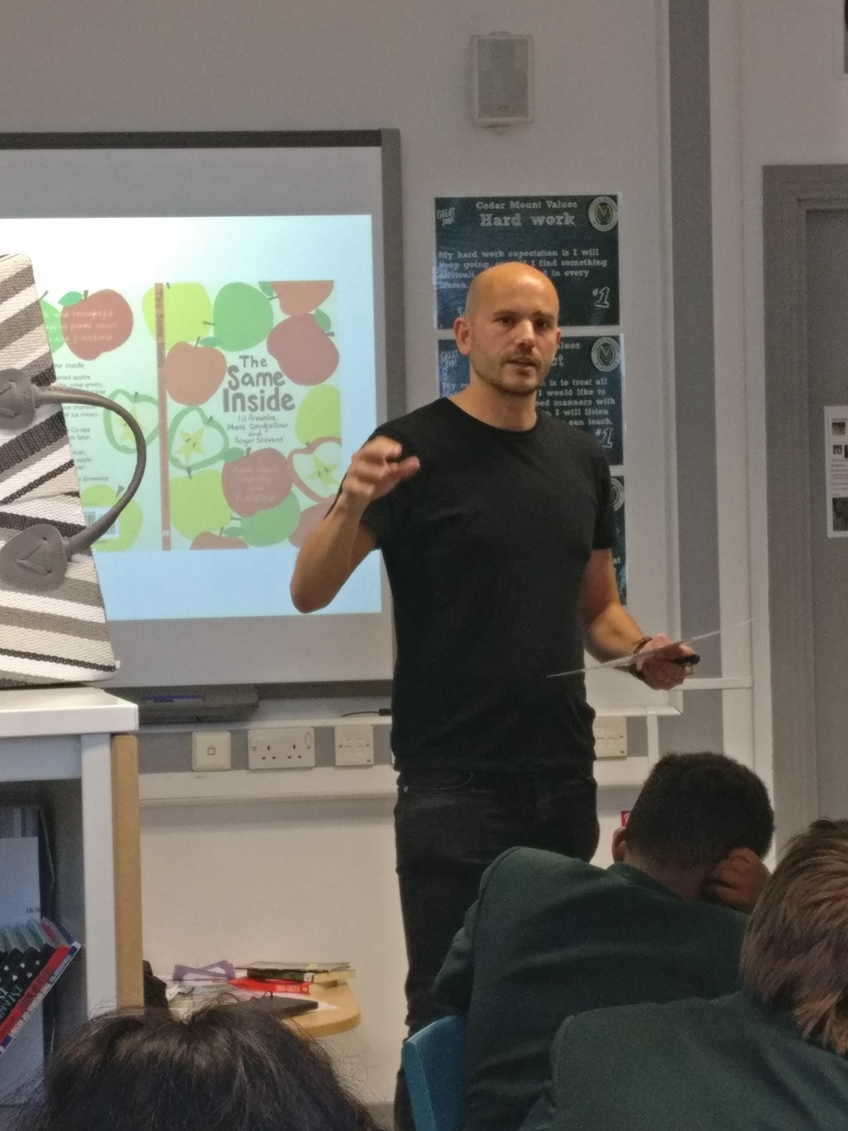
Cedar Mount opened in 2000 as a replacement for Spurley Hey High School and moved to the current site (a new building as part of the Gorton Education Village) in 2008. It is co-located and works well with Melland High School, an outstanding special school also within the Bright Futures Educational Trust.

Cedar Mount has a Published Admission Number of 180 per year group and therefore should have 900 on roll. When the new building opened the school was full but there was a decline across a number of years due to poor exam results and Ofsted outcomes, and the school had 620 on roll in 2016. The school was placed in Special Measures in April 2015 but, after a change of leadership in 2016, standards and pupil numbers began to rise and the school was judged RI in July 2017.

Exam results and progress have improved and are expected to do so again in 2019. The number on roll currently stands at 844 and we expect it to reach 900 for the first time in 10 years in Autumn 2019.

Cedar Mount is situated in South Gorton, the 5th most deprived ward in the country according to the latest set of figures. The Pupil Premium percentage stands at 39.5% currently but this does not reflect the actual situation, due to high numbers of international new arrivals and families not registering for FSM. 65.5% of the school population speaks English as an additional language with 46 different home languages being spoken. There has been a significant shift in the school population in recent years with EAL numbers rising by over 20 percentage points since 2014.

The last 2 years have seen real progress at Cedar Mount and it now needs to be built on and sustained for the students to get the education that they deserve. Students now have much more success in sports (we are City Champions in a range of events), public speaking (we were the top ranked school in the country for Debate Mate in 2018), drama (students have taken part in a range of performances within Manchester) and much more. Students are also able to take part in far more trips, visits and residentials than previously, which is enabling them to improve their knowledge and confidence in a range of areas. Attendance has improved by nearly 2% since 2016 but is still below the national expectation at 94.01%. Behaviour has also shown great progress with fixed term and permanent exclusions reducing significantly; the school is a cohesive community. This is a school progressing well towards a ‘Good’ Ofsted judgement, and expecting an inspection sometime in 2019.

CEDAR MOUNT ACADEMY – PUPIL INFORMATION

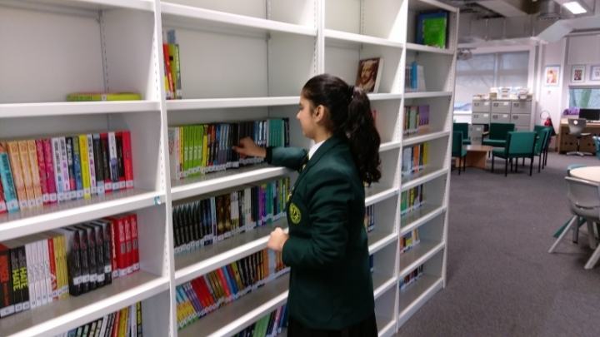

Type: Mainstream School
Phase: Secondary
Funding status: Public - Academy
Gender: Mixed
Religion: Mixed
Age Range: 11 - 16 years
No of students on roll: 833
PAN: 900
SEN Students: 13.6%
EAL Students: 65.5%
Address: Gorton Education Village,
50 Wembley Road,
Gorton,
Greater Manchester.
M18 7DT
Telephone: +44 161 248 7009
http://www.cedarmount.manchester.sch.uk

Cedar Mount Academy is located within Gorton Educational Village in Gorton, East Manchester and shares the campus with two of our partner schools in the Trust; Melland High School, a Special Educational Needs school for 11-19 years and Rushbrook Primary Academy.

Cedar Mount Academy Staffing Structure

The specific responsibilities will be based on the skills and experience of the successful candidate
Staffing numbers in 2018: 63 Teaching Staff; 49 Support Staff

Vice Principal

Salary range L18-L22
(Conditions of service as defined for the Leadership Spine in the current Schoolteachers’ Pay and Conditions Document)
The role of the Vice Principal is to provide vision, leadership and management for Cedar Mount Academy (CMA) and to work in close partnership with the Principal of CMA in all key areas to provide the leadership to continue the transformational journey to ensure the best for everyone, the best from everyone. The Vice Principal will seek to further the effective performance and development of the Academy, its pupils/students, staff and community. He/she will deputise for the Principal when necessary
The Vice Principal, responsible to the Principal, will be the Senior Manager with responsibility for a significant area of Academy policy and practice.. The post holder will share in the responsibility for leadership of the Academy as a member of the Senior Leadership Team.

The Vice Principal will be a successful and experienced teacher in his/her subject specialism, who is able to enthuse, motivate and inspire children, generating a love for learning. The successful candidate will have demonstrated excellent leadership, management and communication skills in his/her present role. Good teamwork, high standards and a capacity for hard work will have been at the core of his/her success. S/he will be a creative thinker with an ability and determination to secure high-quality outcomes for all students.

The Vice Principal will also directly line manage a number of key departments and other middle and senior leaders.

As CMA is a member of the BFET, it is expected that all members of the Senior Leadership Team will also, where appropriate, contribute to the work of the Trust and the schools within the Trust.

Key Responsibilities which will form the basis of specific responsibilities
Excellent progress and achievement for all pupils
- Strategic leadership, direction and development of a key whole school area such as teaching and learning, behaviour and attitudes, or teaching, learning and staff development.
- Leadership of a team of middle leaders to develop the practice of staff in a key whole school area.
- Ensuring that high quality teaching and learning takes place at all times.
- Effective use of accurate data to inform planning and support strategies to raise attainment, secure good progress and address underperformance of groups and individual students.
- Collaboration within the school, the Trust, the Alliance for Learning and external parties such as the local authority and agencies to identify and maximise on opportunities.
- Leading to ensure that all attainment and progress targets are met and improvement is secured.
- Ensuring that a highly relevant curriculum and stimulating curriculum which leads to a range of careers pathways for pupils
- Implement effective, fair and supportive pupil behaviour systems
- Working with the Principal and Vice Principal to ensure that lessons are informed by students’ prior and current data
An environment where our people are valued
- Staff training and development is targeted to needs and measured to ensure that it positively impacts on teaching and learning standards
- Implement the trust’s people policies to ensure that people are recruited, managed, supported and developed appropriately and in accordance with our values and commitments.
- Develop and maintain a culture of high expectations for self and other
- Open and transparent verbal and written communication strategies are implemented with staff, pupils, parents/carers and the local community, as appropriate.
Ensure financial viability
- Contribute to the monitoring of school budgets, for approval by the Principal, which enable robust teaching and learning and value for money
Robust governance and systems and processes
- Provide transparent and thorough materials and updates to the local governing body, in order for them to challenge and hold the school to account and/or to make decisions
- Lead on the establishment of robust systems and processes across areas of responsibility in the academy, ensuring that the impact can always be measured
- Champion all elements to enable a self-improving school system
Community
- Be a visible presence for pupils, parents and the local community and sustain effective and positive relationships
- Work closely with the local authority and agencies as and when required and foster effective and positive relationships
- Take assemblies and participate in break, lunchtime, before and after hours’ supervision.
- Contribute to support programmes for students and staff that may, on occasion, include weekends and holiday periods.
The specific responsibilities will be based on the skills and experience of the successful candidate

Bright Futures Educational Trust is committed to safeguarding and promoting the welfare of children and young people and expects all staff to share this commitment. Any successful applicant will be required to undertake an Enhanced Disclosure check by the Disclosure & Barring Service. This post is exempt from the Rehabilitation of Offenders Act 1974

Vice Principal: Person Specification
Category | Essential | Desirable | Means of identification
Qualifications, Education, training | Degree and/or teaching qualification (PGCE or B.Ed) | Post graduate qualification or professional qualification e.g. NPQSL | Application form/Certificates
Relevant Experience | Successful leadership in a substantial senior management role, demonstrated with outcomes  Track record as a leader, of raising standards and achievement, demonstrated with outcomes  Knowledge of the analysis of internal and external data to support strategic planning across whole school systems.  Current knowledge of leadership of strategies to raise the standard of the quality of education of students in areas such as: teaching and learning, behaviour, attitudes and attendance, curriculum, timetabling and outcomes.  Experience in developing, implementing and monitoring whole-school practice and policy  Successful teaching experience, including at GCSE level |  | Application  Interview  Tasks  References
Our Values | Community: Evidence of working together for a common purpose and encouraging diversity |  | Interview  Tasks
 | Integrity: Evidence of doing the right things for the right reason |  | Interview  Tasks
 | Passion: Evidence of taking personal responsibility, working hard and having high aspirations |  | Interview  Tasks
Pre-employment screening | Enhanced DBS check  2 satisfactory employment references, from the last two employers  Evidence of the right to work in the UK |  | On-line DBS check  References deemed suitable by BFET  Passport or other evidence allowed by UK Home Office

