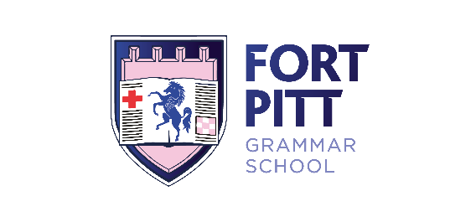
0
Application Pack
Physics teacher

Fort Pitt Grammar School Teacher of Physics Pack
Dear Applicant,
Welcome to Fort Pitt! Thank you for showing an interest in the role of Teacher of Physics here at our school.
We are an outstanding school located on an historical site overlooking the River Medway, with facilities that enable us to provide high quality learning and teaching for our students. We have a brand new, stunning state of the art Science block, which stands alongside some of our older buildings which date back as far as the Crimean War. We are a proud member of a small but beautifully formed Multi Academy Trust of five schools, Fort Pitt being a joint lead school.

Our aim is a simple one; to be the best school in the country, and by that we mean that all of our students receive a better education here than they would if they went to any other school in the whole country. Fort Pitt is a vibrant and dynamic school with high expectations and great ambitions for all of our students.

As a grammar school, academic rigour is part and parcel of our teaching, and we believe that the biggest factor influencing students’ success is the quality of the learning experience they receive in their lessons. However, experience of working in a Grammar School setting is not a pre-requisite, rather we are looking for an outstanding person with the drive, tenacity and commitment to lead our strong learning and teaching to exceptional levels.

This application pack will only give you a little flavour as to what ‘we are all about’ but it gives a good indication. I believe in all of us working together to ensure the best outcomes for the young people we have been entrusted with. They get one chance to get it right, so it is vital we help them every step of the way. I do expect everyone to work hard, but I also want people to enjoy themselves whilst doing so.

We are looking to appoint someone who is ambitious for themselves and for their students. I truly believe that Fort Pitt Grammar School and the Science Department has the potential to become the best in the country in the next few years. If you are up for the challenge of playing a role in helping us to achieve this, and have a core belief that all students no matter what their background can achieve, then we would love to hear from you.

You will find further information on Fort Pitt Grammar School in this pack and on our website, however should you wish to visit please feel free to contact my PA, Lesley Maile, anytime on lmaile@fortpitt.medway.sch.uk or 01634 842359.

I believe that Fort Pitt is a fantastic place to work and hope that having read the information, you agree and decide to make an application.

I look forward to meeting you.

Yours sincerely,

Nicky Archer
Headteacher

About Fort Pitt…

Fort Pitt opened as a grammar school in 1984 and is one of the remaining 163 out of 3109 secondary schools. Prior to this it was the first technical school for girls in the country and opened in 1926 serving the communities of Rochester and Chatham.

Fort Pitt’s history is deep rooted in the local area with its oldest building dating from 1853 when it was a military hospital during the Crimean war and Florence Nightingale’s first teaching hospital. Visited three times by Queen Victoria and Prince Albert, the buildings, estate and school continue to be of national historical significance.

Fort Pitt is one of six selective schools located within the Medway Local Authority area, three of which are single sex 11-18 grammar schools for girls. Much of our intake includes first generation grammar school students as well as first generation sixth-form students and university aspirants. Therefore, one of our key aims and challenges is to raise the aspirations and expectations of both students and parents. Due to this we firmly believe that our school’s mission is to continue the work of the original grammar schools enabling middle and high attaining students from any background to achieve academic success and in turn enable social mobility and increase life chances and choices.

Our class of 2018, like their peers across the country were the first cohort to face the new more challenging
9-1 GCSEs in almost every subject. The students at Fort Pitt showed that they were more than a match for the additional challenges and achieved some of the best results in the school’s history. 99% achieved a good pass (4+) in English and Mathematics, whilst nearly 90% achieved a strong pass (5+), and an excellent 42% of grades were at 7-9 level. This success was replicated at A level, with nearly half of all entries securing an A*-B grade, and students securing university places at top universities including Oxbridge, Exeter, Southampton, Bristol and other Russell Group institutions. Students have also commenced high-level apprenticeships in industries as diverse as accounting and quantity surveying, and started careers in finance and telecommunications.
We are not a ‘super-selective’ school and accept any student who has passed the Medway 11+ test. We do not rank students according to test scores when awarding places, differing from most other grammar schools. Our oversubscription criteria are very inclusive. Our Sixth Form entry criteria has amongst the lowest threshold of any grammar school in the local and wider vicinity and is also lower than many high schools and comprehensives. The Trustees and Governors are committed to keeping the entry criteria as they are so that more students, including boys, have the opportunity to benefit from a grammar school education at KS5, even if they did not have this opportunity at KS3 and KS4.

We are oversubscribed in every year group and draw from a large geographical area which includes Kent and London. Our catchment area is reducing year-on-year and this is a demonstration of our increasing popularity. This year our catchment area has reduced to just 3.193KM, down from over 9KM three years ago.

We are known for having a strong supportive ethos providing an individualised approach to both pastoral care and academic support. This is cited as a reason why most parents choose the school (and why we continue to be oversubscribed) and why our mobility is extremely low. We have a thriving Sixth Form, which became co-educational in September 2013.

Fort Pitt is an ‘Outstanding’ school and its last Ofsted inspection was in May 2009. It continues to provide an outstanding education and exceptional pastoral care. The school was awarded Converter Academy status in November 2010 and since then has sponsored two schools in challenging circumstances by founding the Fort Pitt Grammar School Academy Trust. In September 2015, the Trust merged with The Thomas Aveling Academy, a stand-alone highly successful converter academy in order to form FPTA Academies (Fort Pitt Thomas Aveling Academies) in which both Fort Pitt and Thomas Aveling are Lead Schools.

Fort Pitt is a Leading Edge School, a National Support School and an Initial Teacher Training institution. We have been accredited by the Prince’s Trust Teaching Institute on many occasions and presented with numerous SSAT Educational Outcomes Awards.

The school is comprised of five forms of entry in years 7-11. There is currently an accelerated curriculum in KS3 (years 7 & 8) and an extended curriculum in KS4 (years 9-11).

Fort Pitt is a community comprised of four houses: Meaden, Ryder, Somerville and Westwood. Each house was named by students because of the impact each high achieving woman had on the world. There are various vertical tutor groups in each house made up of students from Year 7 through to Year 13. This long standing mutual support and challenge from cross-age peers makes a significant contribution to our unique ethos and culture giving the students not only an environment of care but also one of future aspiration.
Most importantly, Fort Pitt is a supportive, caring, nurturing, challenging and fun place to study and work.

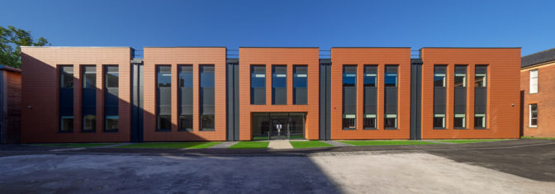

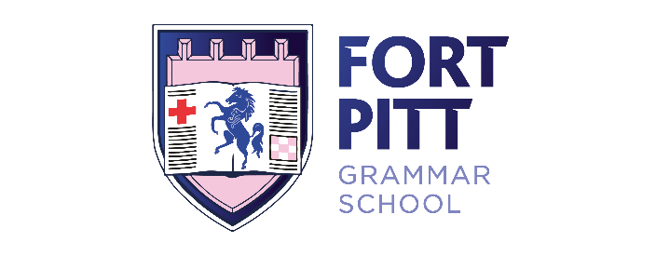
Teacher of Physics
(Potential TLR opportunity; pastoral or departmental)
MPS/UPS FT/PT

We are seeking an inspirational Physics teacher who can deliver high quality lessons, secure outstanding outcomes for our students, and be an integral part of a dynamic and thriving Science department. We want you to inspire students, raise their aspirations and unlock their potential. Applications from both experienced and newly qualified colleagues are warmly welcomed, and previous Grammar School experience is definitely not necessary.
To be successful at Fort Pitt you will:
- Teach to a high standard at GCSE and A’ Level
- Be passionate about learning and teaching
- Have high expectations of all students
- Go above and beyond to ensure students make great progress
- Be committed, hard-working and have a sense of fun!
In return we will offer you:
- A school with really enthusiastic students with a love of learning, and who want to succeed
- A brand new £4m Science building
- An incredibly supportive group of colleagues
- A personalised CPD programme to provide first-rate preparation towards promotion
- A two week October half-term
- The chance to perform on a wider stage through our proud membership of FPTA Academies
- Subsidised membership of Benenden Healthcare
For an informal conversation about the role, please contact Nicky Archer on 01634 842359 or via email on headteacher@fortpitt.medway.sch.uk in order to arrange a time.
Key Information:
Start date: January 2020
Closing date: 12:00 p.m. Monday 14th October 2019
Interviews: As soon as possible after closing date
Fort Pitt Grammar School is committed to safeguarding and expects all members of the school community and applicants to share this commitment. Any offer of employment is subject to satisfactory DBS clearance.
Headteacher: Nicky Archer, BA (Hons), NPQH
 Fort Pitt Hill, Chatham, Kent, ME4 6TJ  01634 842 359  01634 817 386
 office@fortpitt.medway.sch.uk  www.fortpitt.medway.sch.uk

