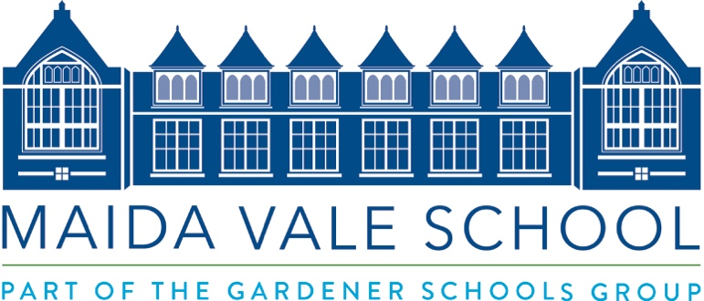

School Secretary and Receptionist Job Description
Term Time Only - plus INSET and 2 weeks

The successful candidate will be flexible and proactive in their approach. Maida Vale School opened in September 2020 so is still in its infancy as a school. This will mean that a wide variety of tasks will fall to the post holder. The chosen candidate will often be one of the first representative of the School that prospective Parents and the wider public speak to; first impressions will be of utmost importance. The role requires an individual excited at being involved in the development of this project with the energy to make it a success.

Responsible to: Office Manager and ultimately to the Headmaster

Our School Secretary and Receptionist will:

- Ensure the front office is a welcoming and well-run environment for Staff, Pupils and Visitors
- Receive Parents, Guests and Visitors in accordance with our ethos and high standards
- Maintain attendance and Pupil records in the Cchool’s Management Information System
- Produce attendance records daily and manage fire register including visitors on site
- To ensure a high standard of administrative and management support for the Headmaster in all aspects of their duties.
- Manage MySchoolPortal – keeping all content including the weekly newsletter and forms up to date
- To enter, manage and analyse data relating to attendance, club lists, visits and Pupil records
- Answer the telephone and direct calls to relevant personnel when necessary
- Deal with School correspondence and direct incoming/outgoing post
- Creating Visitors’ badges for School events
- Supporting Departments with ordering and purchasing.
- Responsible for ordering and purchasing for the School and Head’s Offices
- Assist with First Aid as a School First Aider
- Attend and assist at School functions over and above admissions events as required by the Head.

Hours of Work
Normal hours of work will be 08:00 – 17:00, Monday to Friday.

There will be some occasions when there will be a need to work later in the evenings or a need to be present during an evening or weekend function.

Salary
Up to £28,000 Pro-Rata

Holiday entitlement
This is a term time including INSET days, plus 2 weeks role.

Maida Vale School is committed to safeguarding and promoting the welfare of children and young people and expects all staff and volunteers to share this commitment. All positions are subject to an enhanced DBS check.

To apply, please use the support staff application form on our website
(www.maidavaleschool.com) and email to Angela Miguel (hmpa@maidavaleschool.com)

Closing Date – Wednesday 24th February 12pm

