Chislehurst & Sidcup
Grammar School

Working at Chislehurst and Sidcup Grammar School.
‘Helping the learners of today become the leaders of tomorrow’.

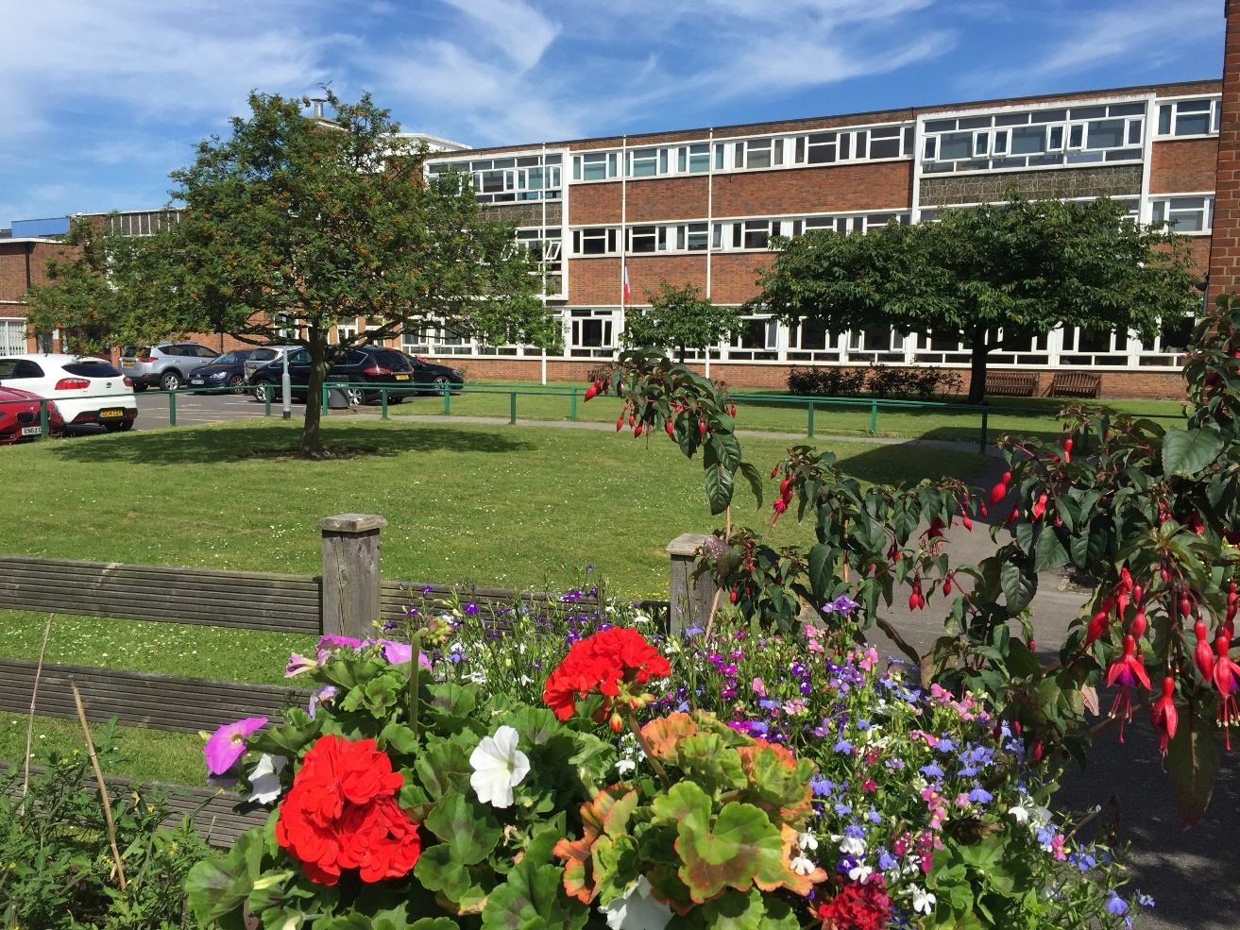


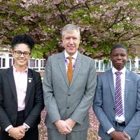

Our school

The school opened in the Autumn Term of 1931 and has been at three different sites since then. 'Chis & Sid' has been at the current site for over fifty years and has undergone considerable building development, ensuring that we have purpose built buildings for Art and Design, Performance and Sixth Form study. There has also been the development of sporting facilities with flood lit netball courts and full gym equipment (which staff are able to use after school).

‘Chis & Sid’ aims to educate and prepare for life, able students from all backgrounds. This mission is dynamically carried forward within a caring, happy and supportive community. We look to develop the character of our students focusing on resilience, intellectual curiosity, courage, creativity, commitment, responsibility, gratitude and compassion. The ingrained idea of excellence in school life allows students to reach the highest academic, sporting, cultural and aesthetic standards. The special quality of learning in the classroom is equally matched by the richness of teaching that students experience. We aim to help our students to leave the school fully prepared for the future ahead of them and, as our school motto states, we believe that ‘from hard work character grows’. Abeunt studia mores.

Whilst healthy academic competition is central to the ‘Chis & Sid’ ethos, there are also many opportunities for students to enter into the wider life of the school. Service to the school and community is enthusiastically performed and high levels of leadership and responsibility are actively taken on by students at all levels. There is a supreme belief that building ‘Chis & Sid’s’ tradition of excellence comes not from dwelling on yesterday’s successes but performing tomorrow’s tasks.

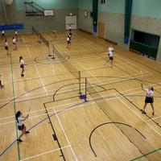
An area that adds to the ethos and culture of ‘Chis & Sid’ is our partnership with a local special needs school. The 16+ students from this school share a purpose built building with our own Sixth Formers and use some of our specialist teaching areas. Our students work closely with the students from Marlborough School with both Year 9 and Year 12 having specific roles and dedicated time to spend with the students from Marlborough School.

The continued success of ‘Chis & Sid’ is matched by an ongoing focus on site development and improvement. Upon extremely attractive grounds, almost unique in the south east of England, a heavy investment programme in new facilities is always taking place to ensure that we provide facilities to support the learning of our students and the work of our teachers.

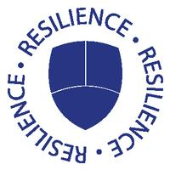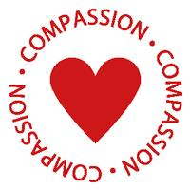

Why join the teaching staff of Chislehurst and Sidcup Grammar School?

Academic success

‘Chis & Sid’ is one of four grammar schools in Bexley and as such our students all pass an entrance examination in order to attend the school. Our results reflect both the hard work of the students and the teachers with the GCSE results for 2019 giving us a Progress 8 score of 0.46 and our A level students continuing to move on to top institutions.

The focus on the academic progress that the students make in the school is evident from the school’s priority to ensure that the academic and pastoral support is on offer with the role of Head of Learning for each year group and a Learning Manager to provide a key link with parents.

Continuing Professional Development

As well as outstanding students who are keen to learn we look to have a happy staff who are able to develop professionally.

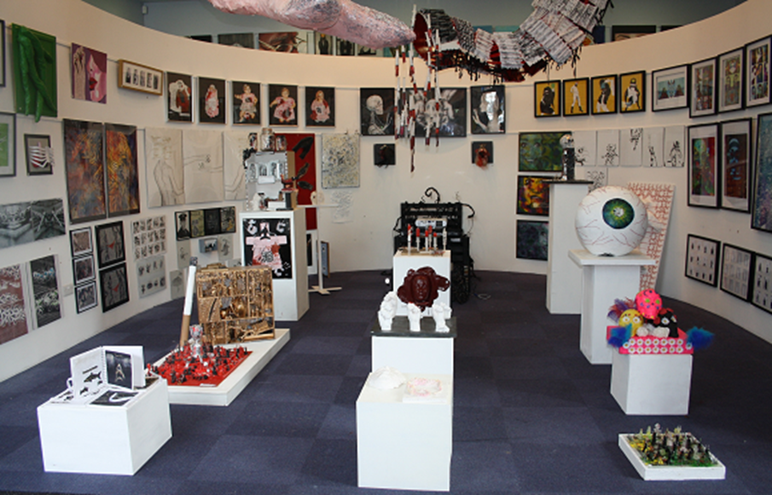
We offer an internal CPD programme that is personalised for a teacher’s needs and takes into account the needs and wants of the teaching staff. There is a clear focus on Teaching and Learning with staff delivering thoughtful and thought provoking sessions that always include opportunities for sharing of good practice and working together collaboratively. This sharing of good practice is encouraged further through all teaching staff being given time to visit another school to share ideas which can be brought back to their curriculum areas. There is also a specific training programme for any Early Career Teachers.

Being part of the Bexley Teaching Alliance also enables us to offer further development for our staff and trainee teachers with Professional Studies sessions being offered collaboratively and the NPQLT programme being delivered by senior members of staff enabling our own staff looking to gain a very strong and accredited qualification the opportunity to do so.

We also work with local schools to further support Curriculum Leaders with regular meetings with the other schools in inter school partnerships.

All new staff are also given a mentor to enable them to have a member of staff that they can go to for any additional support or questions that they may have as well as a member of the Senior Leadership Team being responsible for the Induction of New Staff. Working parties have also been used when staff are looking to develop a key issue.

Wellbeing

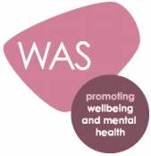
It is of vital importance to us that our staff are happy and enjoy coming to work. In order to enhance this we offer wellbeing sessions where staff have the opportunity to learn a new skill and spend time with other staff. Staff here at ‘Chis & Sid’ are also a close community with staff using the gym facilities, attending yoga sessions, badminton club and mindfulness sessions. The staff society also organise a Christmas party every year.

Our continued commitment to the wellbeing of our staff and students is further evidenced by achieving a Wellbeing Award for the support of the wellbeing of our staff and students.

Additional benefits

Further to this, we offer a competitive pay and pension scheme and to support parents we offer a priority to children of members of staff to join this school (subject to passing the 11+ examinations). We are also an Investors in People employer demonstrating our focus on the happiness and wellbeing of our staff. All staff will also receive a tailored induction programme as well as a professional development scheme (as mentioned above) with the possibility of funding for additional qualifications.

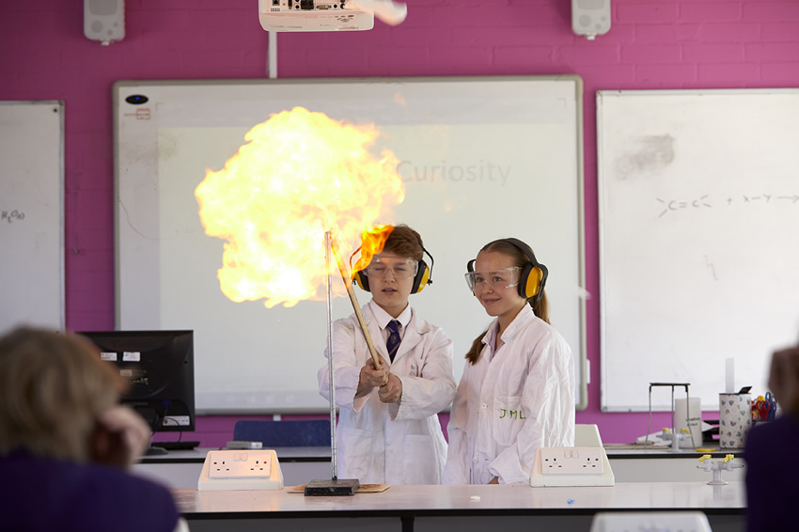

Mission Statement of Chislehurst and Sidcup Grammar School

Helping the learners of today become the leaders of tomorrow
This school aspires to educate, in partnership with parents and students, inquiring, well informed and compassionate citizens who will go on to make a better world by occupying positions of responsibility and influence.

Aims

- To teach with high expectations, striving to ensure students fulfil their potential in both the academic and complementary curriculum.
- To develop inquiring, knowledgeable, creative and articulate lifelong learners.
- To encourage students in leadership and other positive contributions to the life of the school and wider community.
- To encourage students to adopt healthy, physically active and safe lifestyles.
- To develop students who are both happy and capable of future independence.
- To develop students who will respect others, take responsibility for their own actions and become good citizens.
- To ensure students display self-discipline and responsible behaviour that makes a positive difference to the life of the school.
- To develop excellent working relationships between all those involved in the life of the school.

Values guiding the work of staff and students

- To be excellent role models in all we do.
- To strive to make a positive difference.
- To ensure that health and safety are never at risk.
- To show respect for the environment.
- To be calm, polite and fair in all our relationships.
- To allow no place for any form of aggression or violence.
- To act with open-mindedness, understanding and forgiveness.
- To ensure the needs of the individual and school community are in harmony.
- To show respect for each person's unique role in the life of the school.

Curriculum

The school's curriculum is designed to:
- prepare students for the opportunities, responsibilities and experiences of adult life
- be balanced, broadly based, relevant and differentiated to match student needs, aptitudes and abilities
- promote the spiritual, moral, social, cultural, mental and physical development of each student

Students have equal opportunities to the curriculum at all key stages; where options are available, every effort is made to provide students with the options of their choice. Student progress is assessed and the results recorded and reported to parents.
Year 7: On entry, our students study the full range of traditional subjects in addition to either German or French, and Latin as part of Key Stage 3.
Year 8: Students continue to study the full range of subjects as in Year 7.
Year 9: Students continue to study the full range of subjects as in Years 7 and 8. Year 9 also sees our students embark on their GCSE Science. The end of Year 9 marks the end of Key Stage 3 and final assessments are made at that point.
Years 10 and 11: All students take GCSEs in Mathematics, English Language, English Literature, Sciences, either History or Geography, at least one Language subject, Physical Education and Religious Studies.
Years 12 to 13: A Level courses are followed by all students in the Sixth Form – it is expected that all students follow at least three A level courses from the beginning of Year 12, alongside either an AS level in English or Mathematics or the Extended Project Qualification. The range of A Levels offered include:
Art, Biology, Business Studies, Chemistry, Classical Civilisation, Computer Science, Drama, Economics, English Literature, French, Geography, German, History, Latin, Mathematics, Further Mathematics, Music, Music Technology, Physical Education, Physics, Product Design, Psychology and Religious Studies (Philosophy and Ethics).

Details regarding the curriculum covered in specific subject areas is available on the school website.

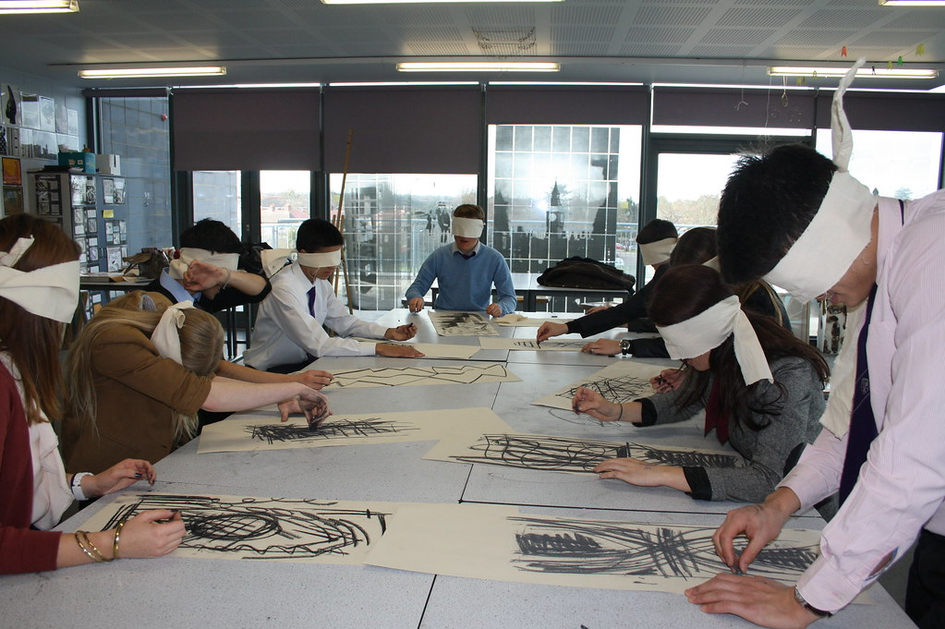

How to apply:

Further details together are available either from the school website www.csgrammar.com (Vacancies) or by emailing csgshr@csgrammar.com. Please complete your application form via www.TES.com. Applications will be considered on receipt and interviews may occur at any stage.

Please note, that we are happy to accept CVs and expressions of interest at any time and may then look at these if a position were to become available. These should be emailed as an attachment to csgshr@csgrammar.com specifying the role that you would be interested in and why you would like to work at Chislehurst and Sidcup Grammar School. If an appropriate position became available you would then be contacted and asked to complete an application form.

If you have any questions, please contact csgshr@csgrammar.com

References

Please note that it is our practice to take up references before shortlisting for interview.
Current and previous employers will be contacted as part of the verification process pre-appointment checks.

When an applicant is short-listed, any discrepancies or anomalies in the information provided or issues arising from references will be taken up at interview. Your referees should include your current/most recent employer. References from relatives or friends are not acceptable.

Safeguarding

Chislehurst and Sidcup Grammar School is committed to safeguarding and promoting the welfare of children and young people. All staff are required, before taking up post, to undertake a criminal record check through the Disclosure and Barring Service (DBS).

Candidates for teaching and support staff posts will be assessed at interview for their suitability to work with children. Appointment is conditional upon at least two satisfactory references, which include specific comments on working with children and young people. All staff at the school have a responsibility to promote and safeguard the welfare of students at the school.

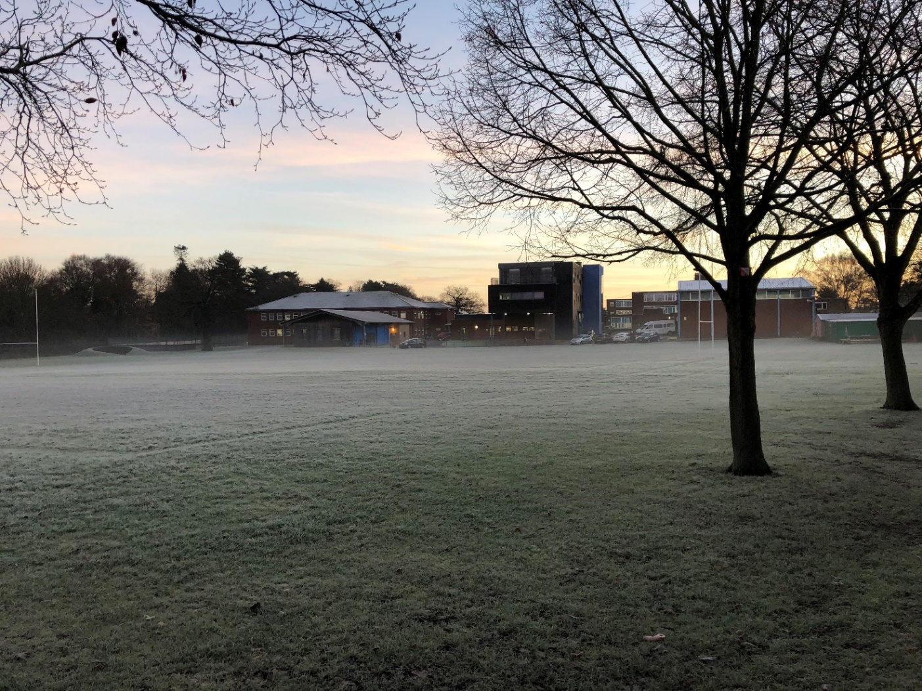

How to find us

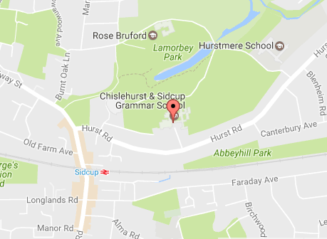
The school is located within a 5-minute walk from Sidcup train station which provides a quick connection to London, has local bus services and is close to both the A2 and M25.

