

**SACRED HEART CATHOLIC HIGH SCHOOL**

**Fenham Hall Drive**

**NEWCASTLE UPON TYNE**

**NE4 9YH**

**Tel: 0191 2747373**

E-mail: [recruitment@shhs.org.uk](mailto:recruitment@shhs.org.uk)

Website: <www.sacredheart-high.org>

11-18 Girls Roman Catholic School

**SIXTH FORM LEARNING MENTOR**

**One Year Fixed Term Contract from November 2022, 37 hours per week, term time**

**Salary: N4 £19,650 - £20,852 per annum (pro rata £16,627 - £17,644) plus 3 call days**

A committed and enthusiastic person is required to join Sacred Heart Catholic High School as a Sixth Form Learning Mentor. The post will include working under the guidance of teachers to:

* Provide academic coaching and mentoring to students
* Lead small groups and support individual students with their academic work to enable them to catch up on missed studies due to the pandemic

Candidates will need to be qualified to degree level with a minimum of a 2:2.

Sacred Heart provides many opportunities for those who want to progress their careers, including the potential for training to become a teacher. Sacred Heart Newcastle SCITT is the largest school-based Initial Teacher Training partnership in the Newcastle and Gateshead area.

The Trustees and Local Governing Committee are committed to safeguarding and the protection of its pupils. The post is subject to an Enhanced DBS check.

Application forms and relevant information are available from our website [www.sacredheart-high.org](http://www.sacredheart-high.org)

**Closing date:** 4.00pm on Friday 4th November 2022

**Interviews:** Thursday 10th November 2022

For applications via email, please send to [recruitment@shhs.org.uk](mailto:recruitment@shhs.org.uk)

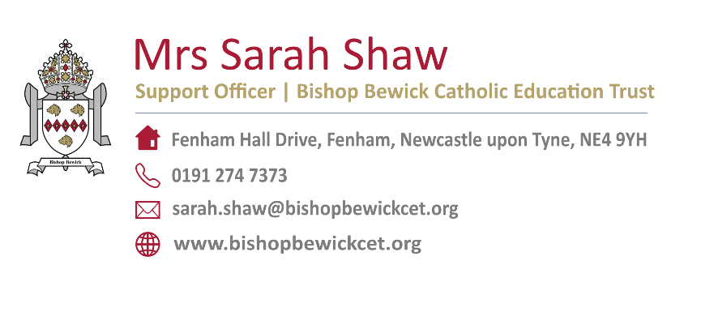



**Sacred Heart Catholic High School part of the Bishop Bewick Catholic Education Trust**