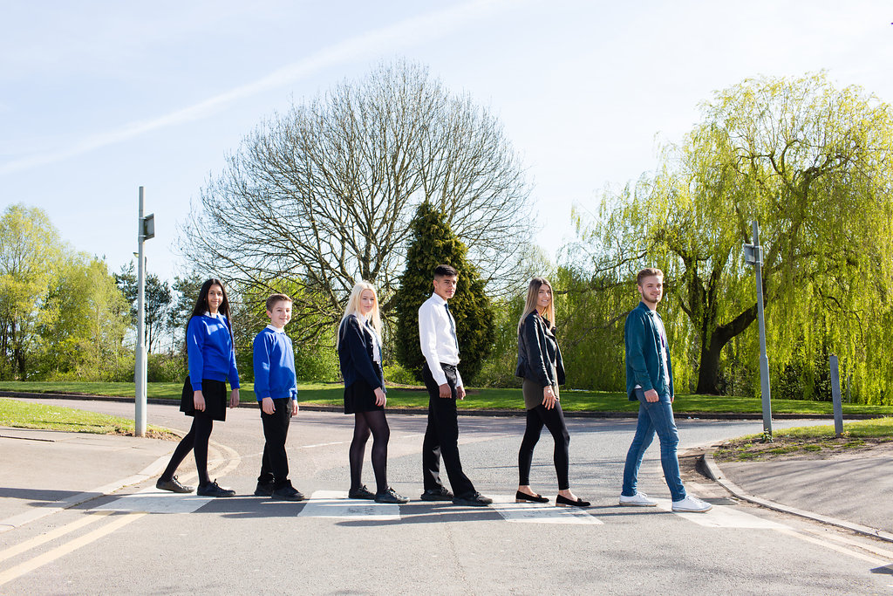

Receptionist

Grade 5, £13,464 per annum, rising to £14,048

37 hours per week, 8am – 4pm, Monday – Friday
Plus 1 week of holiday hours for training, meetings etc.

Content

Vision, Values and Ethos |  | Page 3
Testimonials |  | Page 4
General Information |  | Page 5
The Application Process |  | Page 6
Vacancy Advert |  | Page 7
Letter from the Headteachers |  | Page 8
Job Description |  | Page 9
Person Specification |  | Page 10-11

Vision, Values and Ethos
The shared vision and values of the Trust underpins all that we do, including the governance arrangements for the Trust.

Our Vision
Valuing Everyone, Achieving Excellence

Our Motto
Work Hard, Be Kind

Our goals
The goals of our trust:
- Outstanding levels of progress and achievement for all
- Outstanding levels of wellbeing for all
- Outstanding preparation for adult and working life
- Outstanding family and community engagement
- Outstanding levels of professional learning for all
Informed by “Schools of Tomorrow”

Testimonials
Extract taken from email correspondence, following a tour of the school by a prospective parent
(April 2016):
‘I would just like to say thank you for the time spent with me today on my tour of the campus, and state how impressed I was with the school. There seems to be a very calm, relaxed and organised approach to how the school operates, and I believe that obviously shows in the way your students behave’.

Written comments from parents following Year 9 Progress Evening (2017):
‘My child always talks positively about school to other children the same age, which I think is a good indicator that he is enjoying school’

‘Welcoming, approachable, friendly and knowledgeable staff’.

Written comments from parents following Year 11 Progress Evening (2017):
‘The teachers have pride in their teaching and in the pupils’ progress. They really care and are prepared to go the extra mile to support the students’.
‘My son seems to have progressed so well in most subjects. I feel this is due to good relationships he has been able to form with teachers and the standard of the lessons’.
Written comment from parent at the end of KS5 (2016):
‘This is my final parents evening after my youngest daughter is coming to the end of her years at GCE. Thank you for very happy years for my three daughters and for their excellent education!’
Thank you from parent of ex-student taking up a place at Cambridge University (2013):
‘To all the staff at Brookvale Groby Learning Campusl.
My son has just started at Cambridge University studying Engineering. It was his ambition to go there and this summer, he achieved the grades he needed. We want to acknowledge the great teaching and support he received during his time with you. He progressed well academically, but also grew so much in maturity and confidence. With thanks to you all for your hard work and dedication.’

Extract of letter from staff member:
‘I have thoroughly enjoyed my time on campus. It has been a real pleasure working with staff who are always friendly, extremely supportive and willing to share ideas and knowledge. I have really appreciated having a senior leadership team which is so warm towards its staff and open to their comments and new ideas.

The children I have taught have made me smile, laugh and cry! I will miss my relationship with them and that buzz you get from seeing them progress. It does, however, give me great satisfaction to think that I have put into place schemes of work for pupils and created learning opportunities for them which should continue even after I have left.

I am sad to leave a post which I still love. Once more, thank you for all of your support and kindness.’

Extract of letter from staff member:
‘I have been very fortunate to have worked with amazing people. I have learnt so much as both a Teacher and as a Head of Department.

I will truly miss everyone here, and it really has been an amazing experience. Thank you for allowing me to be part of such a wonderful group of people.

I wish every success to the campus.’

GENERAL INFORMATION

The Brookvale Groby Learning Campus is a highly successful 11-19 educational organisation created from the integration of two schools on the same site. Brookvale High School is an ‘outstanding’ 11-14 school and Groby Community College is a 14-19 upper school graded ‘good with outstanding features’ in its last Ofsted. Together, the campus meets the educational needs of 1,600 students with nearly 400 at Post 16, and we became a Multi Academy trust together at the beginning of April this year.

If you are a highly organised individual, with experience of working within a school environment, who also enjoys working within a busy team, then this is the job for you! Our Receptionists are the first point of contact for all students, staff and visitors to our campus. You can be assured of a lively work place, where no two days are the same.

You will be supported along the way by our current Receptionists and our team of administrative assistants. If you enjoy working with young people and being an effective team member, then we look forward to hearing from you.

The Application Process

Complete application forms should be returned to efreeman@brookvalegroby.com

Or by post to

F.A.O. Elaine Freeman
Brookvale Groby Learning Campus
Ratby Road
Groby
Leicester
LE6 0FP

A letter will be sent to shortlisted candidates with details of the interview process.

Queries

If you have any queries on any aspect of the application or need additional information please contact Elaine Freeman, PA to the Headteacher on 0116 2879921.

Thank you.

The Role

RECEPTIONIST

We are looking for a highly organised and enthusiastic Receptionist to join our busy team.
The successful applicant will be required to work 37 hours per week,
8am – 4pm, Monday – Friday,
plus 1 week of holiday hours for training, meetings etc.
Grade 5 - £13,464 per annum, rising to £14,048.
For further details on this vacancy, or to arrange a visit to our campus,
please contact Elaine Freeman
efreeman@brookvalegroby.com
or call 0116 2879921
Closing date – 9am, Thursday 21st September 2017
Interviews to be held within 2 weeks of the closing date.

Brookvale Groby Learning Campus is committed to safeguarding and promoting the welfare of children and young people and expects all staff and volunteers to share this commitment. Applicants must be willing to undergo appropriate child protection screening, including checks with past employers and the Disclosure and Barring Service.

September 2017

Dear Applicant

Receptionist

Thank you for your interest in the Receptionist vacancy within the Brookvale Groby Learning Campus.

We hope the documents provided help you to gain a feel for the school and if you would like to visit us as well, we would be delighted to show you round. Please contact Elaine Freeman on 0116 2879921 or efreeman@brookvalegroby.com to make an appointment.

All the documents to support this application process are available on our campus website – www.brookvalegroby.com.

To apply please complete the following:

- Application Form
- A letter of application, no more than two sides of A4, word processed using font size no smaller than 10

Your letter needs to be addressed to ourselves, and if you would like to e-mail your application then please send this to Elaine Freeman on the email address above.

The closing time and date for this post is 9.00am, Thursday 21st September 2017. The interviews will be held within 2 weeks from that date. If you have not heard from us by then, please assume that your application has not been successful on this occasion. If this is the case, we would like to thank you for your interest and the time spent in applying.

This post will be subject to an enhanced level Criminal Records Bureau check. All Brookvale Groby employees are expected to promote and safeguard the welfare of students at the school. Our Safeguarding Policy is made known to all and is designed to guide staff, students and parents/carers with regard to Safeguarding issues.

In line with best practice guidance re safeguarding we do not require an additional CV and any included with application forms sent to the school will not be taken forward to the short listing panel.

Yours sincerely
Katie Rush Robert Coles
Headteacher, Brookvale High School Headteacher, Groby Community College
Co-Director of BGLC Co-Director of BGLC

Job Profile

GRADE: 5

HOURS: 37 hours per week, 8am – 4pm, Monday – Friday
Plus 1 week of holiday hours for training, meetings etc

RESPONSIBLE TO: Office Manager

OBJECTIVES:

JOB PURPOSE:

To provide the first point of contact for all students, staff and visitors, in a manner which creates an excellent impression of the friendliness, efficiency and professionalism of the campus.

To assist in ensuring that campus staff and students always have access to a qualified first aider.

KEY DUTIES:

- Provision of reception and clerical services and other campus office duties as required by the Office Manager in accordance with the grade of the post.

- Input information onto computer data base (SIMS.NET) and extract information as required.

- Provide first aid for students and staff as necessary.

- Development of self and others in order to enhance performance, including participation in the school's performance management arrangements.

This post is subject to enhanced disclosure from the Criminal Records Bureau.
All Brookvale Groby Learning Campus employees are expected to promote and safeguard the welfare of students at this school.
The Governing Body and the County Council are seeking to promote the employment of people with disabilities and will make any adjustments considered reasonable to the above duties under the terms of the Equality Act 2010 to accommodate a suitable candidate with a disability.
This Job Description sets out the responsibilities of the post at the time it was drawn up. Such responsibilities may vary from time to time without changing the general character and requirements of the post or the level of responsibility entailed. Variations are a common occurrence and do not necessarily constitute additional responsibilities or warrant a higher grade.
Personnel Specification

 | Attributes Sought
 | Essential |  | Desirable
Qualifications and Professional Development | GCSE English & Maths grade C or above, or equivalent  Commitment to continuing professional development | A  A | First Aid certificate | A
Application | A well written and well presented application, written specifically for this post | A
Experience & Skills | Successful experience of reception / clerical / admin / office work  Experience of working within a school environment  Capacity to form positive relationships with students, staff and parents  Successful experience of being part of a team.  Basic ICT skills  Ability to maintain a calm, caring manner  Ability to work under pressure | A/I/R  A  A/I/R  A/I/R  A/I/R  I / R  I / R | Enthusiasm for becoming involved in the wider life of the campus e.g. extra-curricular activities, school visits etc  Knowledge of SIMS.net | A/I  A/I
Personal Qualities | Good health, attendance and time keeping record.  Willingness to dress and present oneself in line with the ethos of the campus, to inspire the confidence of staff, students and the community | I  I

Evidence to be gleaned from:

A Letter of application, application form and CV
I Interview process
R Reference

In addition to candidates’ ability to perform the duties of the post, all Brookvale Groby Learning Campus employees are expected to promote and safeguard the welfare of students at the school, therefore the interview will also explore issues relating to safeguarding and promoting the welfare of children including:

- Motivation to work with children and young people
- Ability to form and maintain appropriate relationships and personal boundaries with children and young people
- Emotional resilience in working with challenging behaviours
- Attitudes to use of authority and maintaining discipline

Please be aware that any relevant safeguarding issues that arise on receipt of references may be discussed at interview.

