Rawmarsh & Arnold Nursery School Federation

Dear Applicant
Thank you for your interest in the role of Executive Leader across our Federation of Rawmarsh Nursery and Children’s Centre and Arnold Nursery and Children’s Centre.
The recruitment pack contains information which we hope will help you understand our vision for provision for our children and families. I would encourage you to visit the schools and to look at our websites.
This vacancy has arisen because of the retirement of the current Executive Leader. You will see from our Ofsted reports that provision is outstanding across the Federation; the whole school community is very proud of this. We are therefore looking for someone who can continue to innovate and grow with us.
Informal discussions with the retiring Executive Leader are available as are visits to the schools (in line with COVID restrictions).

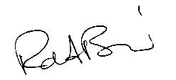
Yours sincerely

Councillor Robert Bird
Chair of Governors

