Head of Computer Science & ICT

MPS/UPS + TLR 2.3

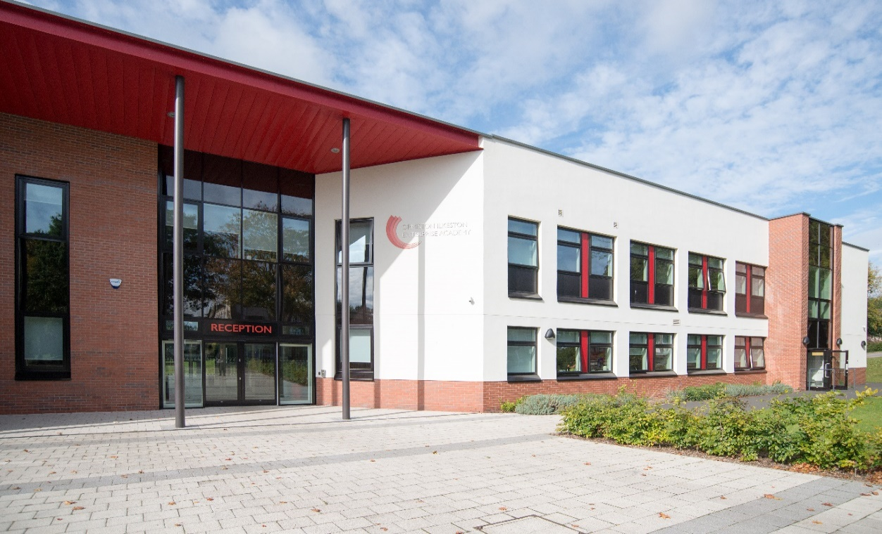

OIEA
King George Avenue
Ilkeston
Derbyshire DE7 5HS
0115 930 3724

facebook.com/oieacademy @oieacademy www.oiea.co.uk
WELCOME

I am so proud to welcome you to Ormiston Ilkeston Enterprise Academy, a school dedicated to achieving the highest standards of teaching and learning.

We work in partnership with parents and carers in order to ensure students achieve
and are fully prepared for their next steps.

We pride ourselves on our calm and purposeful atmosphere around the academy, with high standards for every aspect of academy life.

We strive to work in an atmosphere of trust and to enjoy our education, developing a drive to explore the world in which we live.

Ormiston Academies Trust (OAT) is the sponsor of Ormiston Ilkeston Enterprise Academy.
OAT is a not for profit sponsor of both primary and secondary academies. Their vision is for all young people to have the highest academic, social and practical skills to allow them to lead a fulfilling life. They are determined to become the Trust that makes the biggest difference.

Find out more on the Ormiston Academies Trust website.

The academy is easily accessible to the M1 (J25-26) and the A50 link to the M6. The major city centres of Derby and Nottingham are only 15 minutes’ drive and Leicester, Sheffield and Birmingham are all within 45 minutes travel time.

Ilkeston is also on the doorstep of Shipley Country Park and only a short distance from the Peak District National Park. The local area is an attractive and pleasant place to live, Ilkeston people are renowned for their warmth and humour – it is a close and friendly community in which to work and live.

Miss Nia Salt
Principal

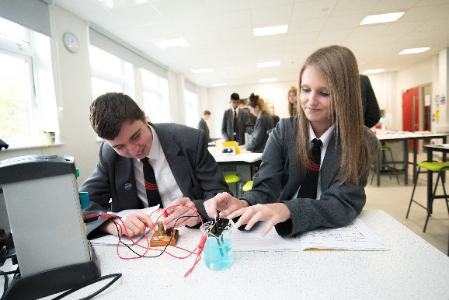
HEAD OF COMPUTER SCIENCE & ICT

Full time/established

Main Pay Scale/Upper Pay Scale
+ TLR 2.3

Required as for January 2020

If you are a teacher who is passionate about their subject, enjoys working with young people and is determined to make a real difference to the children you teach, then this could be the job for you.

We are looking for outstanding teachers and leaders to join this forward thinking academy and develop the quality of teaching and learning. We are seeking to employ teachers who have a thirst to develop young people and build teams committed to academic and pastoral success. This is a fantastic opportunity to play a key role in influencing positive learning outcomes for our students.

This is an exciting time to be joining our new Academy. Our new building houses the English, science and mathematics departments in state of the art facilities. Our Academy is a vibrant and friendly place to teach, with 829 students currently on roll 11-16 yrs. We are pleased to announce that we have again recruited to full capacity in Year 7, with regular
in-year enquiries to join our academy. We offer excellent CPD opportunities for staff at all levels.

For an informal chat or to arrange a visit please contact Oli Forster, Vice Principal, on
0115 9303724.

If you are interested in applying please download the information and complete the application form which can be found at www.OIEA.co.uk/vacancies . Please return your completed application form together with a covering letter saying why you feel you are suitable for the post to lashby@oiea.co.uk.

Closing date for applications: 10 am on Monday 30th September 2019.

Interview date to be advised.

Ormiston Ilkeston Enterprise Academy is committed to safeguarding all our students. Successful candidates will be required to undergo enhanced DBS checks and reference requests will indicate specific questions relating to their suitability to work with children.

Job Description

POST: Head of Computer Science & ICT

SCALE: MPS/UPS + TLR 2.3 (£6,642)

HOURS: Full-time

RESPONSIBLE to: The Principal designated to Vice Principal

RESPONSIBLE for: All Staff deployed in Computer Science & ICT Department

ROLE:

The role of Head of Computer Science & ICT is a key one within the academy, and focuses on raising standards through working with colleagues to ensure teaching is good or better in all lessons and:

- Providing vision, leadership and direction for standards and achievement for the subject to counter any underachievement and stretch the most-able.
- Along with the Vice Principal, being innovative in leading teaching and learning within the subject and being a lead in developing all teaching and learning in the department to be good or better
- To be relentless is sharing and embedding best practice in pedagogy throughout each classroom
- Being innovative in leading curriculum provision within the subject and department
- With the Vice Principal, building an effective team which develops personalised learning and support for students, making sure it drives up standards of achievement and personal development
- Ensuring that standards of provision and achievement of the subjects within the department are at least good and improving
- Actively support the evaluation of performance of the department subjects, particularly the quality of teaching and learning, with the Vice Principal.
- Develop policies and procedures in line with personalised learning and support in the subject, and ensure that resources are well used
- Ensure the smooth day-to-day running of the subject and department with key staff

FUNCTION:

The role of Computer Science & ICT is a vital one. It is a leadership role where the Head of Subject (HoS) leads on a significant aspect of work, with others, to ensure it impacts positively on the quality of teaching and learning in each classroom. It is also a driver for coherent CPD within the Academy and so developing other leaders. Because of this, all HoSs are expected to continue with their own leadership development, for which we have in-house provision.

The following job description is based upon the national standards for leaders. HoS post holders will be responsible for leading across the subject of the department and will be given a clear role within the Improvement Plan for each year, based upon desired improvement.
They are expected to model appropriate leadership at all times to others, and have the following attributes:

- A positive outlook which embraces risk and develops innovation and creativity in others
- Productive engagement in collaboration with others and partnership working, both within the SLT and other collaborations beyond the academy
- Integrity, honesty, courage and conviction to achieve the best outcomes for all learners
- Resilience and perseverance in the face of challenges and change
- To be solution focused in all their leadership
- A drive and ambition for improvement, and so hold people to account and challenge underperformance

TASKS:

Leading Teaching and Learning with the Vice Principal

- Excellent knowledge of pedagogy to ensure that learning is good or better in each classroom through coaching and the spreading of best practice.
- Models new ways of teaching and learning and so demonstrates professional expertise. Uses department meetings and other planned opportunities to develop teaching and learning
- Gains sophisticated self-evaluation evidence on which to build plans to improve outcomes.
- Ensures that the leadership of each subject in the department leads to raised quality of teaching and, attainment and achievement.
- Uses relevant meetings and other planned opportunities to develop teaching and learning within the department.
- Knowledge of the Ofsted criteria for teaching and learning and ensuring that evaluations of this aspect are accurate and sophisticated.
- Ensure that there is appropriate identification and implementation of provision to meet the CPD needs of colleagues and improve further their performance.
- Applying knowledge of the subject leadership to select and implement appropriate monitoring activities to inform self-evaluation practices.
- Identify and model good and better “behaviour for learning” strategies for consistent use throughout the department.
- Contribution to the academy’s plan in relation to good or better care guidance and support.
- Support and then monitor the department and individual staff in setting appropriately challenging targets for themselves and students.
- Monitoring the provision and accuracy of data from internal assessments, so tracking the attainment and achievement of all students and groups of learners to ensure that they are on track reach their targets.

Leading People with the Vice Principal

- Good understanding of significance of interpersonal relationships and impact on outcomes.
- Constantly developing self and others in ways to improve classroom performance and outcomes.
- Good understanding of how CPD and Performance Management lead to sustained improvement in outcomes.
- Searches for feedback about own performance from others so to improve further.
- Promotes the sharing of best practice through coaching questioning and feedback to others
- Constantly developing self and others in ways to improve classroom performance and outcomes.
- Develops and supports systems to build capacity for teams.
- Creates a culture which encourages ideas and contributions from others.
- Can negotiate and manage conflict and provide appropriate support

The HoS is responsible to the VP for all teaching and learning issues and standards.

Performance Management

- Line-manage staff in the subject – both teaching and non-teaching.
- Support the VP in ensuring effective performance management for staff.
- Monitor and challenge professional standards within the department to ensure teaching improves continually
- Develop the strategic goals of professional development within the department
- Ensure equity in staff development

Personnel

- Participate in selection of new staff
- Carry out duties associated with the mentoring, coaching and development of staff
- Support the process on threshold, UPS references, promotion, induction and ITT

Duties and Responsibilities – General

- To adhere to existing practices, methods, procedures, undertake relevant training and development activities and to respond positively to new and alternative systems.
- It will be necessary to work with information technology and associated systems in accordance with academy/County Council policies
- To co-operate with the academy in complying with relevant health and safety legislation, policies and procedures in performance of the duties of the post.
- To carry out the duties and responsibilities of the post in compliance with the academy’s Equal Opportunities policies.
- To maintain confidentiality and observe Data Protection and associated guidelines where appropriate.
- To understand and comply with the academy’s environmental policies.
- To carry out any other duties which may be reasonably regarded as within the nature of the duties and responsibilities of the post as defined, subject to the proviso that normally any changes of a permanent nature shall be incorporated into the job description in specific terms.

DBS/SAFEGUARDING STATEMENT
Ormiston Ilkeston Enterprise Academy is committed to safeguarding all our students. Successful candidates will be required to undergo enhanced DBS checks and reference requests will indicate specific questions relating to their suitability to work with children.

PERSON SPECIFICATION

Post: Head of Computer Science & ICT

Scale: MPS/UPS + TLR 2.3 (£6,642)

Responsible to: The Principal designated to Vice Principal

Essential Requirements | Method of Assessment  A = Application  I = interview
- Experience/Qualifications/Training
- Qualified teacher status | A
- To have undertaken relevant CPPD during the last two years. | A
- To be an exciting and innovative classroom teacher | A & I
- To have successful teaching experience across KS3 and KS4. | A
- To have experience of curriculum planning, devising schemes of work and managing a team of teachers. | A
- Abilities
1. The ability to lead, manage and work as a member of a team. | I
2. The ability to motivate staff through personal influence, purposeful leadership and  concern for others. | I
3. The ability to motivate and engage students in the learning process through personal  influence and concern for individual needs | I
4. The ability to initiate, lead and manage on-going curriculum innovation to improve  teaching and learning. | A & I
5. The ability to work to targets and monitor progress | I
- The ability to plan and organise high quality lessons | A & I
- The ability to assist in developing and implementing faculty policies and systems | I
- The ability to communicate effectively and build purposeful professional relationships with colleagues and students | I
- Special knowledge
1. To understand the learning process and educational needs of youngsters | A & I
2. To understand the personal, emotional and social needs of students | I
3. To have a clear understanding of the statutory curriculum requirements of the specific  subject/curriculum area | I
- Commitment
- 1. Commitment to the academy’s values and principles, aims and  - policies. | I

Ormiston Ilkeston Enterprise Academy is committed to safeguarding all our students. Successful candidates will be required to undergo enhanced DBS checks and reference requests will indicate specific questions relating to their suitability to work with children.

