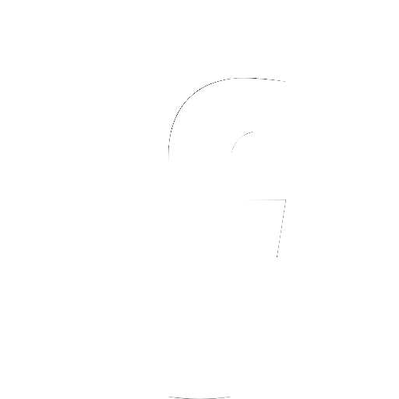
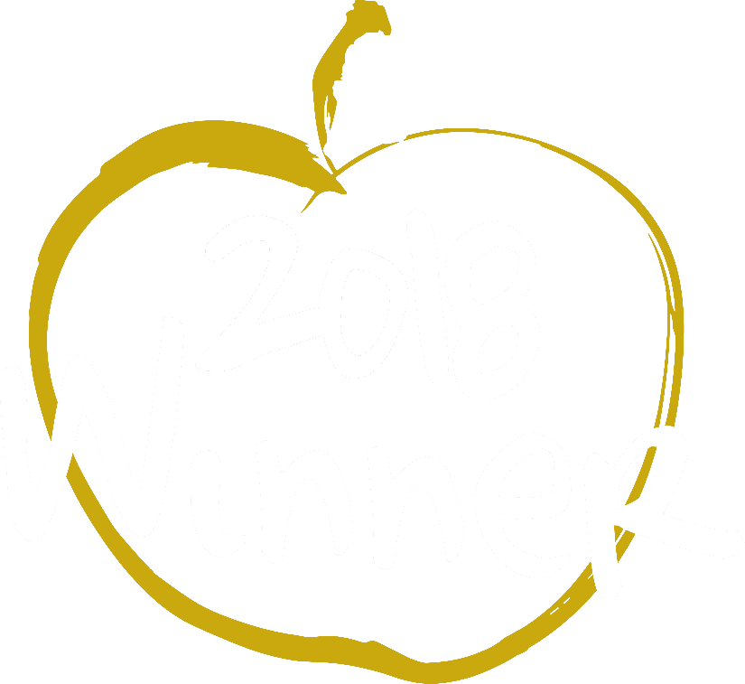
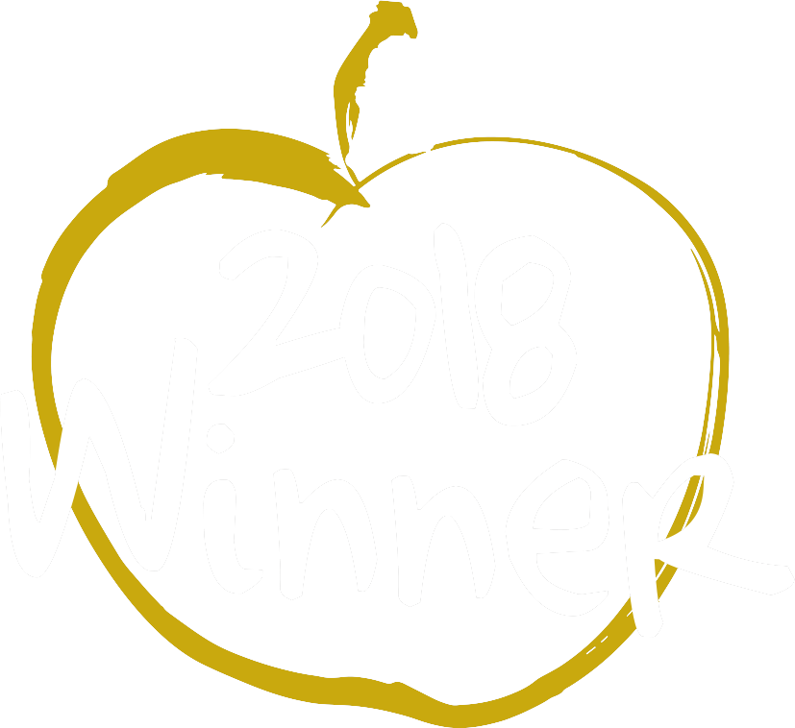
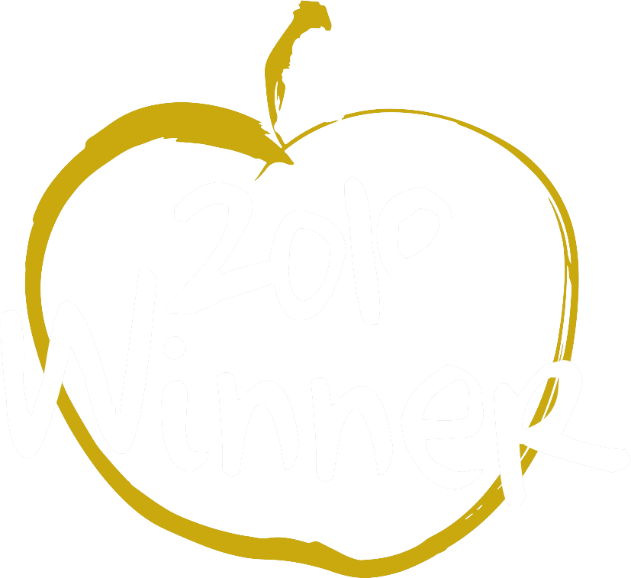
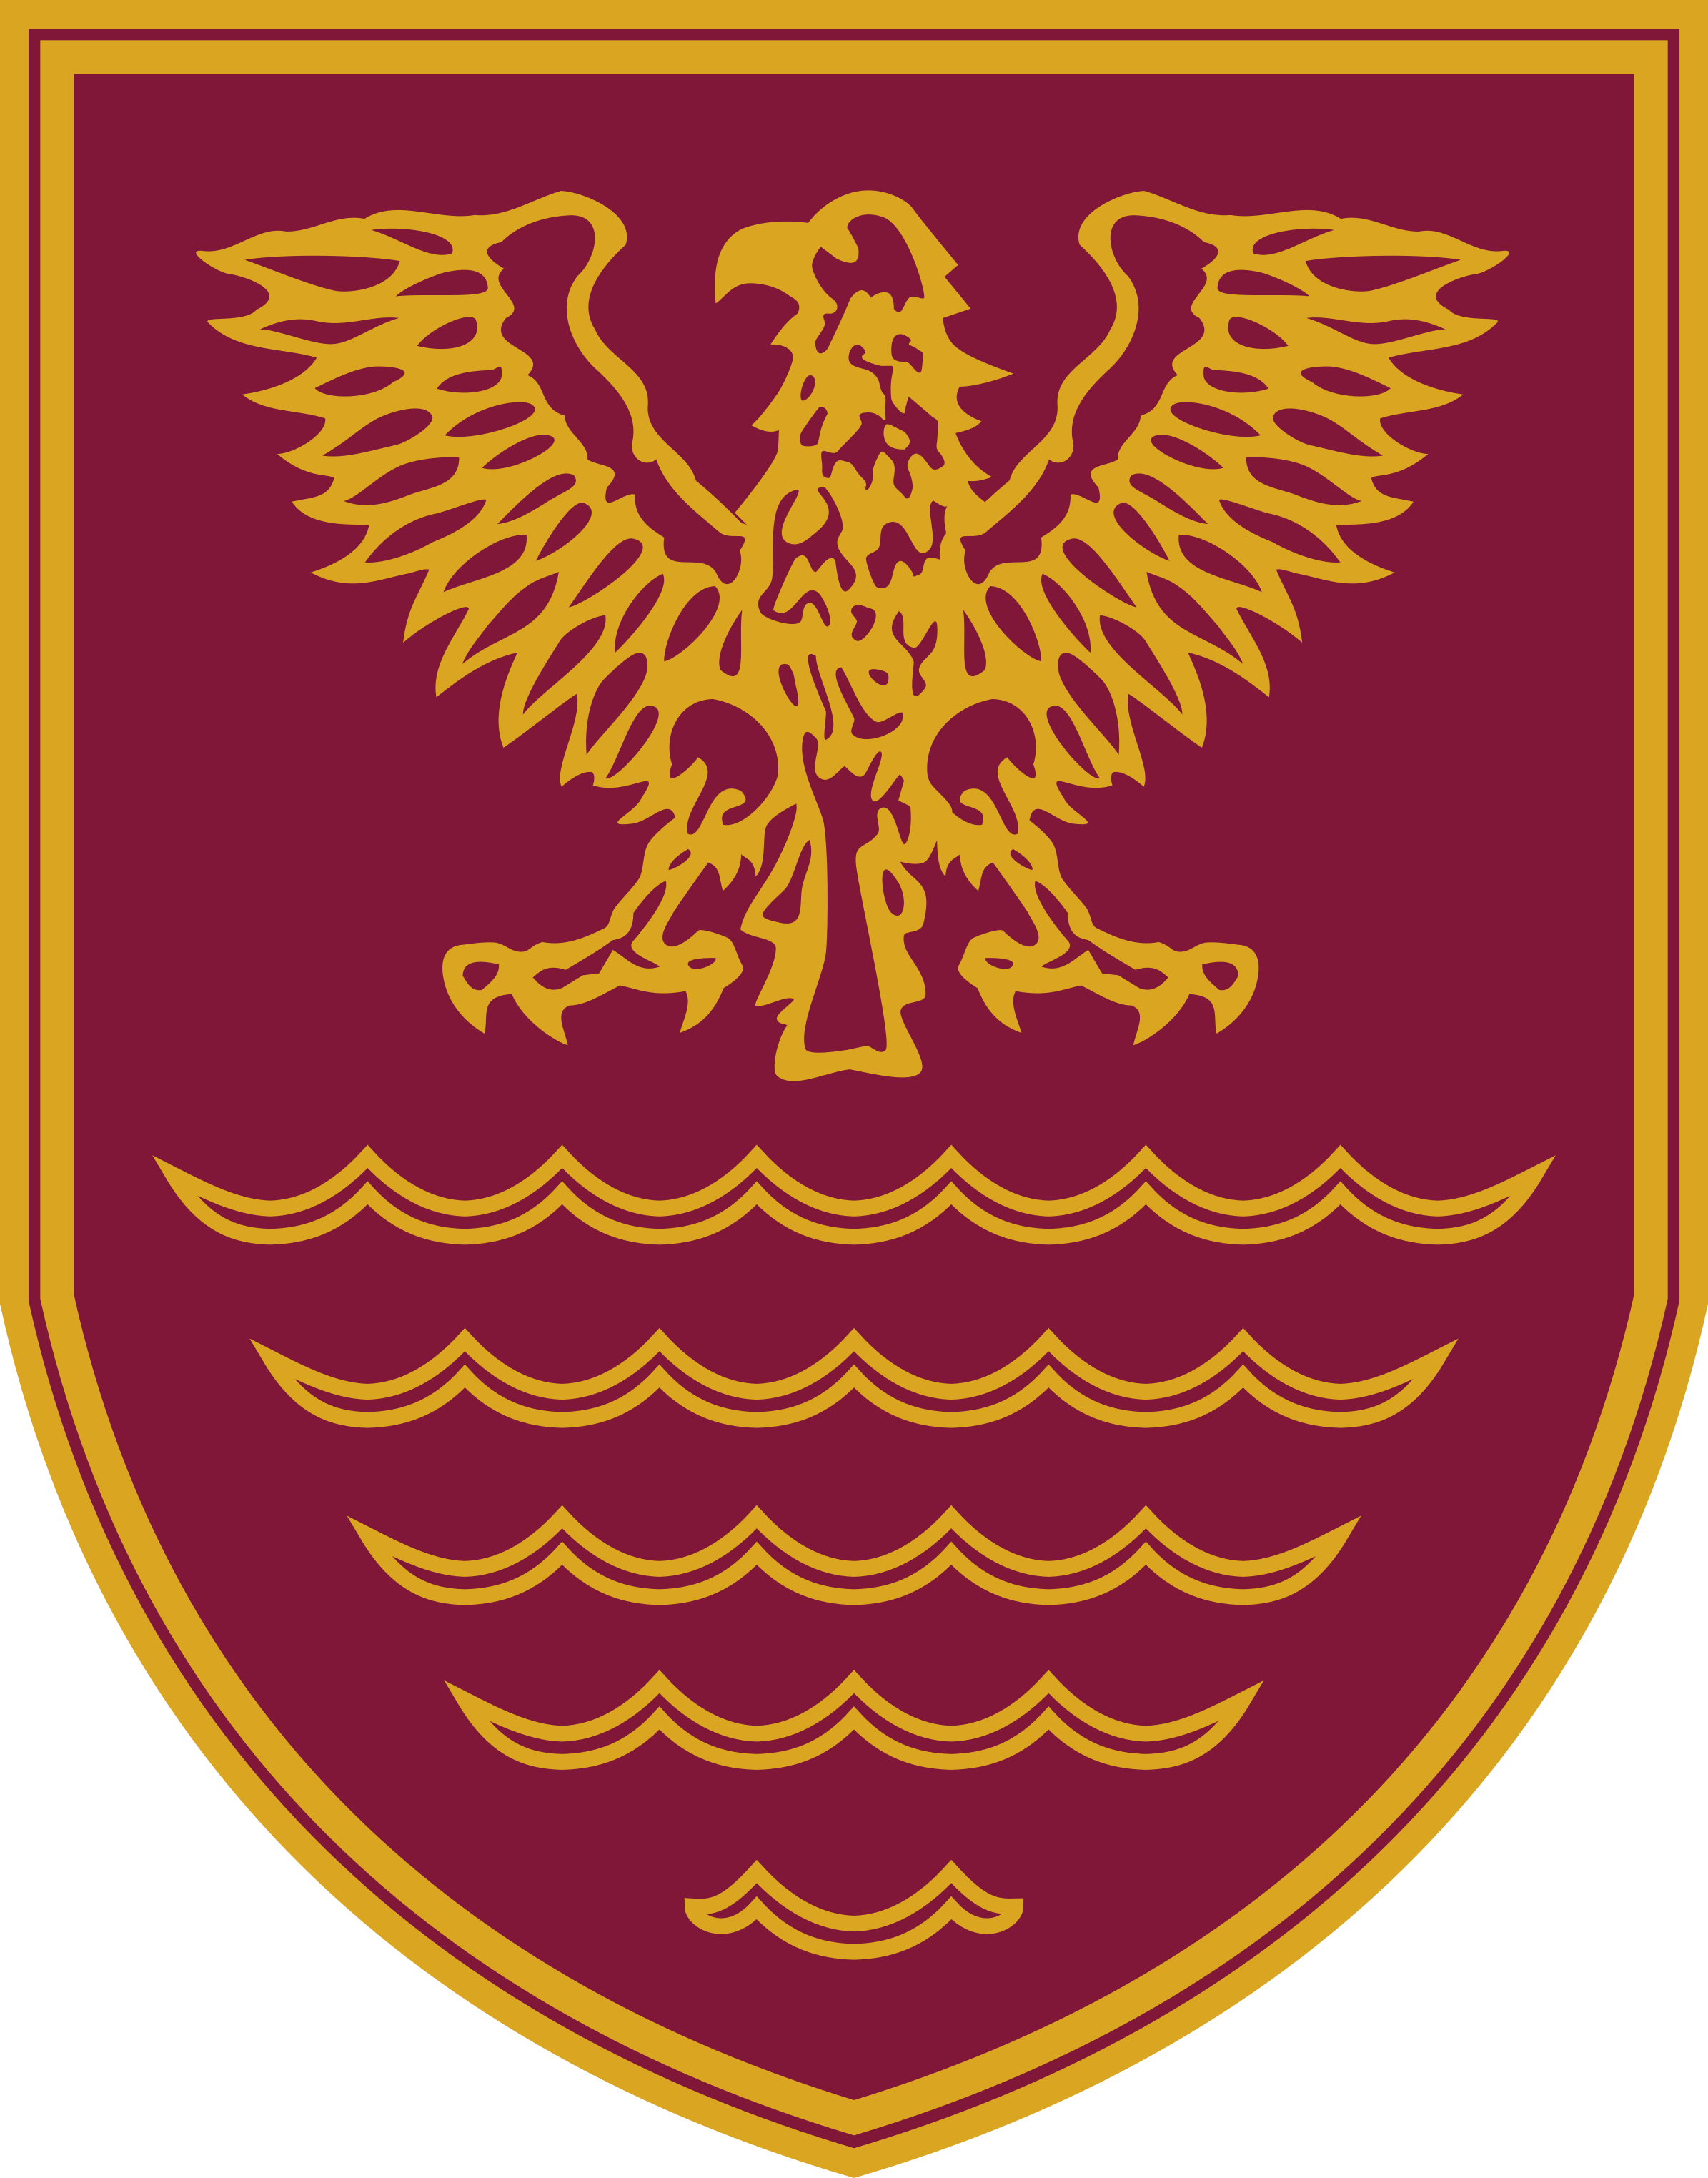

SENIOR TEACHING ASSISTANT.
Required as a permanent position; applications for a full-time, part-time or a job share will be considered.
We are looking to recruit two full time Senior Teaching Assistants to join our excellent Learning Support Team, to work under the guidance of the SENCO and teachers across the key stages to support our learners with SEN.
’Relationships throughout the school are excellent.’ Ofsted, 2018.
We are an inclusive school, we employ people who have a passion for supporting students, enabling them to reach their potential. The ability to work constructively with students and to establish excellent relationships is paramount.
‘There is great mutual respect between pupils and their teachers.’ Ofsted, 2018
Experience of working with students who have SEN is desirable and candidates would need to have an NVQ Level 3 or equivalent qualification, including English and maths GCSE grade 4 or above, or equivalent.
‘The supportive and can-do culture in classes inspires pupils to learn.’ Ofsted, 2018.

If you require any further information, please contact Mr David Tromans – Headteacher on:
Tel: 01900 813434
Email: d.tromans@netherhall.cumbria.sch.uk
Closing date for applications: Friday 20th January, 2023
Interviews to be held on: Week beginning Monday 23rd January, 2023
References will be requested before candidates are called for interview.
Netherhall School is committed to safeguarding and promoting the welfare of young people and expects all staff and volunteers to share this commitment.
The successful candidate will be subject to pre-employment checks including an enhanced DBS (CRB) check.
‘Staff and pupils say, without question, the Headteacher has been an inspiration, giving them belief that all can achieve. Throughout his tenure, the Headteacher has demonstrated passion, integrity and highly skilled leadership. This school has been transformed in a remarkably short period of time.’ Ofsted, 2018.

Netherhall School
An Ambitious, Caring Community

‘Pupils love coming to school’ | ‘Pupils are proud of the school’ - Ofsted, February 2018

BEST SECONDARY SCHOOL 2018

BEST STUDENT & BEST TEACHING PROFESSIONAL 2019
Find us on Facebook: @NetherhallSch
www.netherhall.cumbria.sch.uk

