

Published: 29 October 2019

Application deadline: 9.00am Monday 11 November 2019

Candidate brief

Teacher of Classics

(from September 2020)

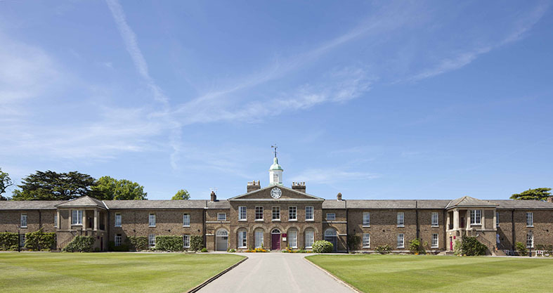



Life at Haileybury

Haileybury is an outstanding British independent

co-educational boarding school. We offer modern boarding and day provision for eight hundred boys and girls aged 11–18. Established in 1862, we are situated on a glorious, historic 500-acre campus in Hertfordshire, just 20 miles north of London and 35 miles south of Cambridge.

Ours is a happy, purposeful and tight-knit community where more than 90% of the teaching staff live in College accommodation, either on campus or within walking distance of our beautiful site. This helps create a unique atmosphere in which to work.

We focus on creating a warm, nurturing environment which is particularly evident in the Lower School, a “school within a school” for Years 7 and 8, which includes its own Boarding House, Highfield. Boarders and day pupils join one of 12 houses when they enter the main school (Years 9 to13). This creates strong “family” groups of about 55 pupils per House.

An appreciation of the wider life of a seven-day-a-week boarding school is a prerequisite for a successful career at Haileybury, along with a willingness to immerse oneself in the boarding and co-curricular programme. The three aspects to every full-time teaching role are: teaching, tutoring in a Boarding House and involvement in co-curricular activities. Teaching staff are also expected to attend Chapel services.

* The School provides a welcoming, vibrant community whether you are a young, single NQT or a more established professional with or without a family.
* The School puts great emphasis on excellent CPD and career development opportunities with regular internal training, and opportunities to pursue further training outside of the School.
* There is also the opportunity for great music making for musicians of all abilities and opportunities to be included in concerts.
* There is a vibrant sporting community with opportunities to join staff sports teams and use our world class facilities.
* The vast majority of members of the teaching staff live on site and thus avoid commuting.
* Members of the teaching staff are part of a wider Haileybury family which comprises our sister schools in Kazakhstan, our alumni and Haileybury Turnford, a local state maintained academy sponsored by Haileybury.
* There is easy access to all the academic, cultural, social, sporting and retail facilities on offer in London and Cambridge.

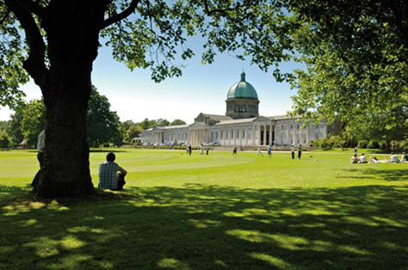



Curriculum and results

At Haileybury, we encourage academic excellence and promote intellectual curiosity. A combination of a robust, creative curriculum, inspirational teaching and an atmosphere in which the progress of every pupil is important, ensures that the learning at Haileybury is of the very highest quality.

We are an academically selective school, providing a wide range of (I)GCSEs and in the Sixth Form a choice of A Level or the International Baccalaureate (IB) Diploma. Our all-round pastoral care extends to pupils and staff alike and is underpinned by our open, embracing Christian ethos that welcomes equally those of faith and no faith. This nurturing environment, together with extensive co-curricular activities, creates confident individuals, with leadership, team and social skills. We deliver what many schools only promise – a truly holistic education in which our pupils are prepared for university and life beyond as global citizens.

Haileybury combines excellent scholarship with forward-looking teaching. In pupils and teachers alike, our aim is to nurture a love of learning and a desire to explore new ideas. In so doing we prepare pupils to develop academically and to achieve at their highest level. Their endeavours are supported by outstanding facilities, study resources and enrichment opportunities.

We offer a broad curriculum where pupils study for (I)GCSEs, and either A Level or the International Baccalaureate Diploma. We also provide a dedicated Lower School for years 7 and 8 and our innovative curriculum is built on the twin principles of subject-specific knowledge, and wider application of this knowledge through project based work.

In summer 2019 Haileybury pupils excelled in their (I)GCSE results. 44 % of grades were awarded at A*/8/9, with 65% awarded at A*/A/9/8/7, the second highest figure in the school’s history. Furthermore, 20% of grades were awarded at 9, against a national figure of 5%, with 20 pupils achieving straight A*/A or equivalent. A level results were also very positive. The overall figure of just over 70% A*/B at A level was the strongest since the reformed qualifications were brought in in 2015. The average IB Diploma points score for pupils was 36.2 points out of a possible 45, well above the worldwide average, and maintaining the exceptionally high standards set in recent years. One pupil attained the maximum of 45 points and 90% were awarded the A* / equivalent. When A level and IB results are combined, just under half of all of our results in the Sixth Form were A*/A, or equivalent, and just under 80% of results in the Sixth Form were A*/B or equivalent.

Our pupils traditionally gain places at Oxbridge, Russell Group universities and leading international universities in Europe, the Far East and the USA.

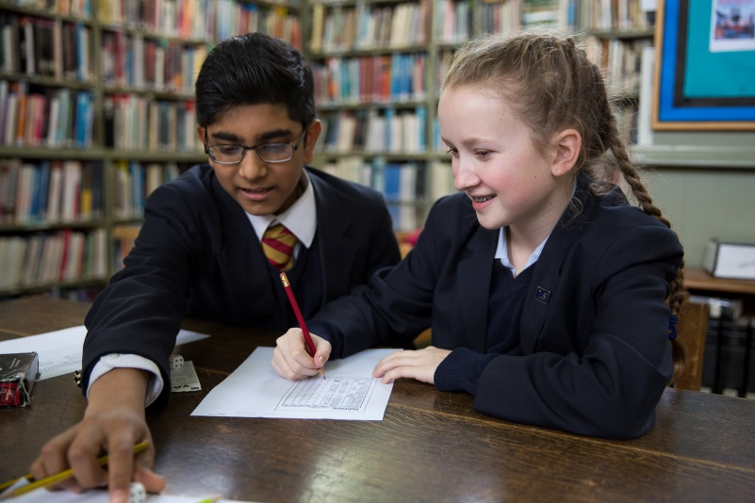



The Department

**Staffing**

Classical Subjects are studied by almost half of the pupils at Haileybury. The department consists of five full-time teachers with an excellent blend of youth and experience. As a department we encourage pupils to engage with intellectually stimulating and enriching material. Pupils feel confident to pursue their own interests and combine Classics with subjects across the curriculum, and we have an excellent record of students studying Classical subjects at university.

**Curriculum**

All pupils study Latin in the Lower School (Years 7 and 8). Pupils can then choose Latin, Greek and/ or Classical Civilisation in Removes (Year 9).  All three subjects are then offered at GCSE and A Level, with Latin also taught at both Higher and Standard Level in the IB.

**Examination results**

The department consistently achieves excellent examination results. In 2019 our pupils achieved 100% A*/A in A Level Classical Greek, with similarly impressive results in both Latin and Classical Civilisation. Results at GCSE have also been outstanding, with over 90% 9/8/7 in Classical Greek. The department has also seen great success with the IB course, with 100% achieving over 5 points across the two levels in Latin. Every year Haileyburians successfully apply to read Classics and related courses at Russell Group universities. We also provide a number of opportunities alongside the curriculum for pupils pursuing Oxbridge applications; they are regularly successful.

**Co-Curricular**

Numerous trips, organised by the department, are available to Classicists throughout the year. Pupils have the opportunity to see Classical plays in London, visit museums and galleries or attend university lecture days. Further, we have offered an annual sixth form trip to Rome or Sicily, a Middle School trip to Greece and a Lower School trip to Naples.

The College’s flourishing Classical Society hosts numerous events all year round. These vary from sixth form led talks for KS3 pupils to Classical careers events and lectures by academics. A symposium discussion group also gathers regularly to encourage pupils to examine a wide range of material outside of their syllabus.

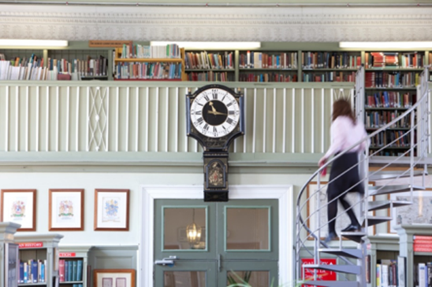



The role

Haileybury wishes to appoint a well-qualified and suitably experienced teacher of Classics.

**Purpose of the position**

To fulfil the teaching requirements as directed by the Head of Department, according to the overall aims of the school. The teacher must be able to teach Latin and Classical Civilisation in the Sixth Form and if possible Greek to at least junior level. They can expect to teach classes ranging from Year 7 to Year 13.

To offer support to the learning, pastoral and co-curricular needs of the individual students through the house system as a tutor and the co-curricular programme. These duties should be carried out to a high standard to ensure the all-round quality of education for pupils at Haileybury.

The teaching week currently consists of 37 periods of 40 minute lessons from Monday to Saturday lunchtime, together with games on Tuesday, Thursday and Saturday afternoons and activities including CCF on a Wednesday afternoon. A normal teaching load for a full time teacher is 26 periods per week.

All professional duties are outlined in the Contract of Employment, the associated Employment Manual and the Staff Handbook. Here is an extract of the key responsibilities and tasks:

**Key responsibilities**

* Ensure the best possible academic outcomes for pupils through planning, preparing and delivering courses and lessons to a high standard.
* Assess, mark, record and report on the development, progress and attainment of pupils in line with College and Departmental policy; providing timely and supportive feedback to pupils on their work following the agreed policies in the Staff and Departmental Handbooks with regard to such matters as programmes of study, teaching methods, supporting pupils with Learning Support needs and homework (prep).
* Maintain a stimulating teaching environment and exercise proper care of teaching materials, equipment and rooms.
* Advise on and co-operate in the preparation and development of courses of study, teaching materials, teaching programmes, methods of teaching and assessment.
* Promote the general progress and well-being of individual pupils and groups of pupils.
* Participate in arrangements for further external training and professional development as a teacher.
* Work with and inspire a tutor group of young people, as part of a wider team of year group and boarding house tutors following the expectations set out in the Staff Handbook.
* Supervise pupils as part of a boarding house tutor team; this will include carrying out an evening boarding house duty, and occasional Saturday evening and Sunday commitments.
* Share responsibility for all pupils within the College (especially those in your teaching or tutor groups) in liaison with appropriate Heads of Department, Housemasters and Housemistresses and senior managers.
* Maintain good order and discipline among the pupils and safeguard their health and safety both when they are on the College premises and when they are engaged in College activities elsewhere.







Benefits package

Accepting an offer of employment at Haileybury is as much about a lifestyle choice as it is about pursuing a satisfying career path. The School has high expectations of its staff and therefore looks to reward them with an attractive benefits package, which includes:

* The salary will be attractive and this will be discussed on appointment. School accommodation will be provided on campus or close by. Accommodation might be provided rent and Council Tax free.
* The package includes fee concessions of 75% for the children of any member of the full-time Teaching Staff who meet the School’s entry requirements as well as membership of the Teachers’ Pension Scheme. Members of the teaching staff also have use of the School’s world class sporting and leisure facilities.
* There are also the usual benefits found at other independent schools such as longer holidays than the maintained sector, access to a private healthcare scheme, free lunch when on duty (Haileybury is known for its high quality catering), typically generous sickness and maternity arrangements.
* The Common Room is welcoming and you will have access to refreshments throughout the working day. The school also has a resident Doctor and full-time Health Centre as well as a resident Church of England Chaplain.
* The School is in a fabulous location, surrounded by Hertfordshire countryside but travelling from Haileybury is very straightforward:
  + Central London is 35 minutes away by train (via Broxbourne station).
  + Cambridge is 50 minutes away by car.
  + London Stansted Airport is just 30 minutes away by car.
  + London Heathrow Airport is 50 minutes away by car.
  + London Luton Airport is just 40 minutes away by car
  + Key routes north and east/west, the A1 and M25 are 20 minutes away by car.

Relocation issues

For families considering relocation issues there are several primary and prep schools in the area. There are a large number of staff children in the village primary, Hertford Heath Primary School. Other staff children attend a variety of schools including Roselands Primary School in Hoddesdon, Heath Mount Prep School in Watton at Stone, and Duncombe Prep School in Bengeo.

Equal Opportunities

Haileybury is an equal opportunities employer and is committed to a policy of treating all our employees and job applicants equally. It is our policy to take all reasonable steps to employ and promote employees on the basis of their abilities and qualifications without regard to age, disability, sex, gender reassignment, pregnancy, maternity, marital or civil partnership status, race (which includes colour, nationality and ethnic or national origins), sexual orientation, trade union membership, religion or belief.



The vacancy

**Working hours:** This is a role requiring regular commitment in evenings and weekends during term time given the nature of the school. It will also require some periods of time in formal school holidays in relation to co-curricular trips, for example.

**Probationary period:** The appointment is subject to the receipt of satisfactory references, the successful outcome of a Disclosure and Barring Service Enhanced Disclosure and completion of a one year probationary period.

**Applications** should be made on the staff application form and include a covering letter, outlining the reasons why you are interested in the role and any additional information you would like to add. CVs are not accepted. Please address to: The Master’s PA, Haileybury, Hertford SG13 7NU. Or please send a scanned copy to teacherrecruitment@haileybury.com

**Closing date and selection process:**

Completed applications must be received by 9.00am Monday 11 November 2020.

Interviews will take place within 2 weeks of the closing date. If applicants have not heard from the School by 01 December 2019 they should assume their application has been unsuccessful.

**Documents required at interview:** All safeguarding checks must be completed prior to the employee starting work at Haileybury. Therefore, in order to facilitate this process all candidates are required to bring the following documents to the interview:

* valid passport
* UK driving licence (both parts if applicable)
* UK birth or marriage certificate
* two documents as proof of address e.g. a utility bill and a bank statement
* proof of your National Insurance Number e.g. National Insurance Card or a previous P45 or P60

In addition to the above, please bring to the interview all proof of relevant qualifications and courses undertaken. Originals only will be accepted, do not bring photocopies.

**Disclosures:**

We will appoint, train, develop and promote on the basis of merit and ability alone. It is a stipulation of the Governors and a statutory requirement that members of staff appointed to Haileybury should be shown not to have any criminal record which might prevent them accepting a post at the College. Accordingly, Haileybury requires permission from all members of staff to make an appropriate investigation. Offers of employment are subject to a satisfactory outcome of this enquiry.

**Safeguarding & Child Protection:**

All applicants must be willing to undergo child protection screening, including, but not limited to, reference checks with previous employers, prohibition checks and a criminal record check via the Applicants Disclosure and Barring Service (including Barred List Check). All offers of employment are conditional upon the satisfactory outcome of child protection screening checks.

**Overseas applicants:** Applications are welcomed from applicants not currently resident in the UK and these applicants may at the College’s discretion be interviewed by Skype.

If you have any questions regarding the interview process please contact the Master’s PA in the first instance on 01992 706 482 or email teacherrecruitment@haileybury.com



Travelling to Haileybury

Haileybury is located in rural Hertfordshire between Hertford and Hoddesdon about 20 miles north of

central London

Air travel: London Heathrow (50 minutes by car), London Stansted (30 minutes by car) and London Luton (40 minutes by car) airports are within easy reach of Haileybury. London Gatwick Airport (75 minutes by car) is only slightly further away. All are served by rail links to central London.

By rail: There are two main line railway stations close to Haileybury. Hertford North to London (Moorgate or King’s Cross) is a 40-minute journey. Broxbourne to London (Liverpool Street) is 35 minutes. Hertford North is a five minute car ride from Haileybury and Broxbourne is 10 minutes away.

By road: Haileybury is conveniently located close to the A10 and easily accessible via the M25, A1(M), M11 and A414.

• From the South East: Leave the M25 at junction 25 to join the A10 north (Cambridge), exiting the A10 at Hoddesdon.

• From the South West: Leave the M25 at junction 21a to join the A405, then the A414 to Hatfield and on to Hertford. The B1197 leads to Hertford Heath village.

• From the North: Leave the A1(M) at junction 4 for the A414 to Hertford, or leave the M1 at junction 7 (St Albans) for the A414 to Hertford.

• From the East :Via the M11 leave at junction 7 (Harlow) for the A414 to Hertford.

