Reed’s School Job Description
IT TECHNICIAN
Reed’s School is committed to safeguarding and promoting the welfare of children and young people and expects all staff and volunteers to share this commitment.
The Department and Role: | Reed’s School has a large IT network, spanning multiple buildings and based primarily around a Microsoft server and clients. There are small apple networks.  The majority of the servers are virtual, running VMWare on a SAN. Operating systems are mostly Windows Server 2008 R2/Windows Server 2012 R2 and the workstations are running Windows 7 Enterprise 32bit/Windows 10 Education 64bit.  There are also approximately 250 iPad devices issued to staff and pupils.  The Cisco Meraki wireless network typically supports 1500 BYOD client devices each day.  The school uses SIMS as its MIS, with the Bursary using WCBS and Development Office using Raisers’ Edge databases.  The School operate Follow Me printing which is structured around PaperCut MF and MFDs across the site.  The School is working on various IT projects currently, to be completed by 2021. These include expanding the iPad scheme to all pupils in Years 9-11 and all telephony being IP based.  This role-holder will provide general IT support to all members of the school, pupils, staff and Governors.  This role will report into the IT Director.  Please see the organigram below which provides an overview of the structure of the IT department and reporting lines.  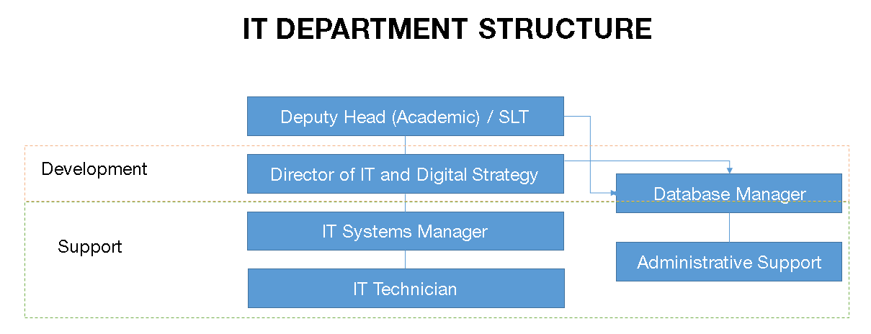
Main Duties and Responsibilities: | - Maintain four IT labs – monitor printers, replace paper/toner and generally keep the rooms in good order.  - Provide technical support to all Teaching and Support staff and student bodies at Reed’s School.  - Work within a Helpdesk environment with ticket escalation, recording all support activities.  - Assist with the installation and upgrade of hardware and software, completed during the school holidays.  - Offer technical support and training to those non-IT specialist teachers who use the dedicated Computer Rooms, and to other staff members where required.  - Assist in supervising the computer rooms during morning break, at lunch times and after school.  - Assist with projectors, interactive whiteboards and AV equipment.  - Promote and safeguard the welfare of children and young persons for who you are responsible and with whom you come into contact.  - Undertake such other comparable duties as the Headmaster requires from time to time.

Reed’s School Person Specification
IT TECHNICIAN
Reed’s School is committed to safeguarding and promoting the welfare of children and young people and expects all staff and volunteers to share this commitment.
 | Essential | Desirable
Experience: | - Experience of working co-operatively as part of a team.  - Experience of working with IT systems. | - Experience of working in the IT Department of a school.
Skills: | - Good planning and organising skills.  - Good communication skills.
Knowledge: | - Microsoft Windows 7.  - Office 365 and Microsoft Office 2013.  - Basic knowledge of Microsoft Networking.  - Printer maintenance.
Personal competencies and qualities: | - Motivation and enthusiasm to work with children and young people.  - Ability to act as a role model for pupils and staff through demonstrating high standards of personal and professional conduct.

