Bordesley Green Girls’ School & Sixth Form
Applicant Information Pack
@BGGS_Birmingham
Careers and FE Advisor and Business Links Manager

Headteacher’s Welcome

4 July 2019

Dear Applicant
I am delighted you are interested in joining the team at Bordesley Green Girls School and Sixth Form. We are proud of our students and of our School. Our students are highly ambitious and from our Sixth Form they move onto the UK's top Universities or to Apprenticeships in some of the country's leading companies.
We work hard every day to ensure our students receive the very best state education available and to encourage them to believe in themselves. They are hardworking, ambitious and generous and they take pride in their own achievements and in their School.
Community support is a huge strength of the School and we are developing growing range of partnerships with Universities, Colleges and successful businesses.
Our Governing Body has three highly esteemed academics on the board as well as finance and safeguarding experience from leading practitioners in their field. Our parent Governors keep us grounded. Together, the Governors, the Senior Leadership Team and staff all work in harmony to deliver a great education for our students.
We encourage applications from colleagues with a diverse range of skills and experience. We work hard and we celebrate our achievements. We are a School which wants our staff to succeed every bit as much as our students.
I look forward to reading your application.

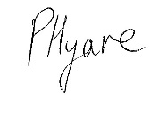

Ms P Hyare
Acting Headteacher

Bordesley Green Girls' School & Sixth Form is a high achieving, over-subscribed, four-form entry 11-18 multi-cultural, inclusive comprehensive school situated on the eastern side of the City of Birmingham. We have 1,000 students on roll including 360 in the Sixth Form.
The Governing Body is currently looking to appoint a dynamic and experienced
Careers and FE Advisor and Business Links Manager
Grade 3, TTO + 10 days, 36.5 hours/week, permanent
Start Point 9 – 11 £20,344 - £21,166 (pro rata), depending upon experience
Start Date: September 2019
In this key role you will maximise the successful entry of our students into the world’s top Universities, FE Colleges and Apprenticeship schemes by ensuring all our students are provided with information, advice and guidance to access further education, training and the workplace in order for them to achieve their personal goals and career aspirations. The successful candidate will:

- Provide careers advice in preparation for curriculum choices at 14+, 16+ and beyond in line with the national statutory Gatsby Benchmarks
- Advise on the preparation of UCAS applications for university
- Grow and develop an engaged network of parents, alumni, business partners and other friends of the school and community such as MOSAIC, to provide mentorship, work experience and to co-ordinate networking events
- Develop robust relationships with Universities, FE Colleges, vocational institutions and the business community, including the Chamber of Commerce, the CBI and local employment agencies to identify opportunities in the job market, work experience, apprenticeships and internships
- Ensure a comprehensive programme of pre-employment advice and training is available for our students so they are job ready upon leaving the Sixth Form
- Develop, wide-ranging and engaging enrichment interventions for our Sixth Form students
The ideal candidate will have experience of the university admissions and UCAS application process with experience or knowledge of Schools and School curriculum and a Careers, Education, Information and Guidance (CEIAG) qualification or equivalent.
If you can empathise and support students, providing personal warmth to gain their confidence and encourage them to progress and succeed we would be delighted to hear from you.
Further details and an Applicant Information Pack are available on our website at www.bordgrng.bham.sch.uk
Please submit your completed application form to HR@bordgrng.bham.sch by the closing date:
12 noon on Tuesday 16 July 2019. Interviews will be held on Thursday 18 July 2019.
If you would like to arrange a visit to our School & Sixth Form, please email the HR mailbox and we will be happy to arrange a tour for you.
If you have not heard from the School within 10 working days of the closing date, please assume that your application has not been shortlisted on this occasion.
We are committed to safeguarding and promoting the welfare of children and expect all staff to share this commitment. An Enhanced DBS check is required for all successful applicants.

Job Description: Career and FE Advisor and Business Links Manager
Purpose: | To maximise the successful entry of our students into the world’s top Universities, FE Colleges and Apprenticeships schemes by ensuring all our students are provided with information, advice and guidance to access further education, training and the workplace in order for them to achieve their personal goals and career aspirations.
Starting Date:  Accountable to: | September 2019  Head of Sixth Form
Responsible for: | - Providing careers advice in preparation for curriculum choices at 14+, 16+ and beyond in line with the national statutory Gatsby Benchmarks  - Advising on the preparation of UCAS applications for university  - Growing and develop an engaged network of parents, alumni, business partners and other friends of the school and community such as MOSAIC, to provide mentorship, work experience and to co-ordinate networking events  - Developing robust relationships with Universities, FE Colleges, vocational institutions and the business community, including the Chamber of Commerce, the CBI and local employment agencies to identify opportunities in the job market, work experience, apprenticeships and internships  - Ensuring a comprehensive programme of pre-employment advice and training is available for our students so they are job ready upon leaving the Sixth Form  - Developing wide-ranging and engaging enrichment interventions for our Sixth Form students
Key Factors of the Role: | - Increasing our success rate in applications to world class Universities  - Developing an explicit programme of activities to stretch and challenge our most able students and to market these widely to existing and prospective students  - Ensuring our Sixth Form students are appropriately challenged, supported and engaged in the achievement of their ambitions  - Being an external ambassador as a speaker at conferences and networking events in marketing our Sixth Form provision within the local and National marketplace  - Maintaining our position as a centre of excellence in Higher Education and Careers Guidance
Liaison with: | - University admissions tutors regarding course requirements, candidate suitability and entry statistics  - Relevant School staff including the Head of the Sixth Form, Heads of Year, Form Tutors and subject teachers to ensure relevant information and advice is given to individual students  - Parents requesting advice by phone, e-mail, or in discussions within School  - Employers, businesses and charities potentially able to offer work experience and employment opportunities for students  - Research bodies and funding agencies in order to seek out opportunities for our students to get involved directly in projects.
Contract: Full Time, Permanent, term time only + 10 days, 36.5 hours per week
Starting Salary: Grade 3 Point 9 – 11 £20,344 - £21,166 (pro rata)

General Requirements
All School staff are expected to:

- Maintain confidentiality according to the organisation and legal requirements
- Uphold School policies, routines and codes of conduct as set out on Firefly (VLE)
- Undertake other such reasonable duties as may be required from time to time
- Work towards the School’s vision and objectives
- Be aware of and adhere to the Child Protection and Safeguarding Policies
- Support and contribute to the School’s responsibility for safeguarding students
- Work to promote equal opportunities for all students and staff, both current and prospective
- Maintain high professional standards of attendance, punctuality, appearance, conduct and positive courteous relationships with students, parents and colleagues
- Engage actively in the performance management review process
- Show a willingness to undertake training and professional development either in-house or externally

Safeguarding Statement

BGGS and Sixth Form is committed to safeguarding and promoting the welfare of children and young people and expects all staff and volunteers to share this commitment. An enhanced DBS check must be completed for all successful applicant.

Signature: …………………………………… (Postholder) Date: …………………………………………….

Signature: …………………………………… (Postholder) Date: …………………………………………….
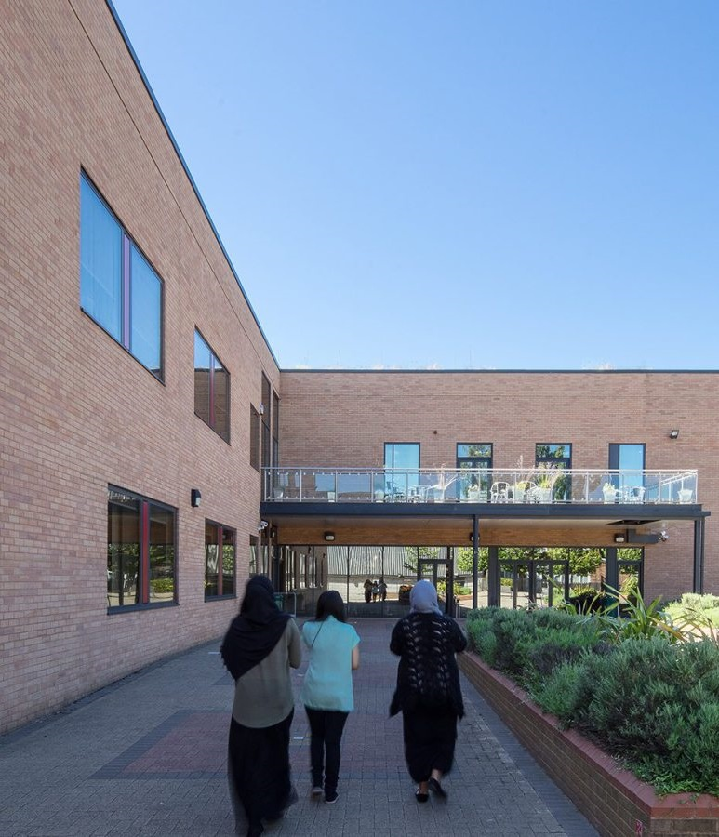
Person Specification for Careers and FE Advisor and Business Links Manager
Essential Requirements
- An up to date knowledge of career options and alternative career paths for
- A CEIAG qualification or equivalent
- Experience of the UCAS application process
- Excellent communication skills: particularly the ability to listen, empathise and support students
- Experience or knowledge of working in a School and Sixth Form with an understanding of the School curriculum
- Ability to network effectively within the community and the wider marketplace
- Ability to develop robust and engaged relationships
- Ability to work efficiently, effectively and to meet deadlines, including when under pressure
- Able to communicate concisely and knowledgeably orally and in writing to a variety of audiences
- Excellent presentation skills
- Excellent interpersonal skills
- Ability to work as part of team
- Attention to detail
- Excellent organisational skills
- Excellent in the use of ICT
- Ability to manage and deal with confidential data/issues appropriately.
- Personal warmth to gain confidence of students, staff, parents
- High work standards evidenced by consistently thorough, detailed, organised approach to work
- Collaborative, flexible and supportive when working in a team environment
- Impressive personal presence and presentation
- Commitment to ongoing improvement and desire for excellence
- High levels of discretion and confidentiality
- Proven track record of delivering advice and guidance in a 1:1 and group setting
This post is covered by Part 7 of the Immigration Act (2016) and therefore the ability to speak fluent spoken English is an essential requirement for the role.
Desirable Requirements
- Knowledge of work experience and or volunteering programmes/opportunities
- Experience of training in interview techniques
- First Aid Qualification or willingness to undertake training

